Dusty Digest.

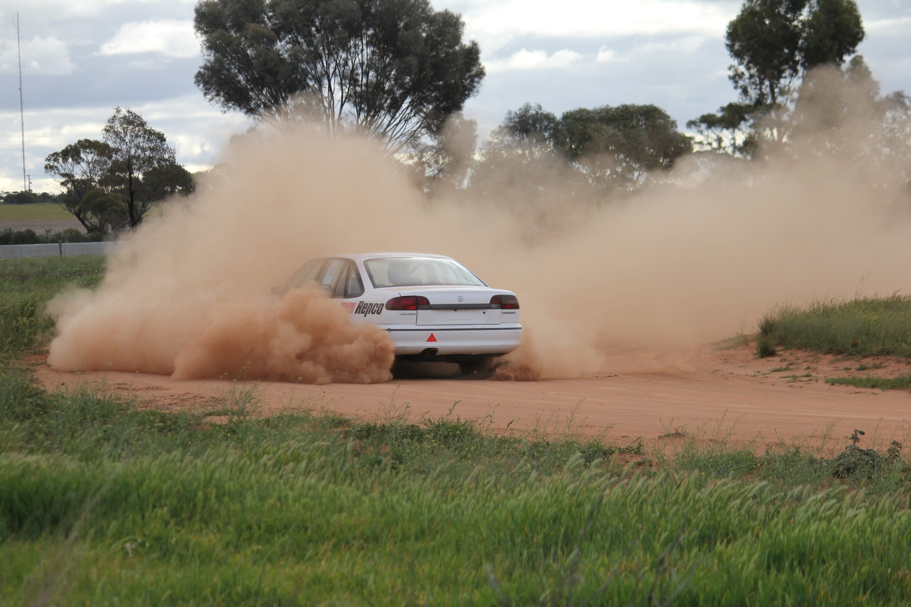

Ed’s Note Pg 2

Prez’s Report Pg 3

Tips and Tricks Pg 7

Working with Children Checks Pg 11

Contacts/Next Meeting Date Pg 13

Event Calendar Pg 14

Not-So-Random Pics Pg 14

We Love Our Sponsors Pg 16

**Swan Hill Sporting Car Club**

**Newsletter**

**August 2017**

**Editor’s Note**

You could have been forgiven for thinking that the August event must have been our Retro Round. Not only was the old Club Sigma back in the pits but the Ex Mr Dust Falcon ute was hanging around like it had never left, rust, battlescars and all – only the drivers had changed. A blast-from-the-past ex-Sigma pilot showed he’d seen the light and turned up in – gasp – a Commodore – and speaking of Commondores, a whole fleet of them arrived, reminding old bogans like myself of the days when a big heavy RWD Holden was the thing to have in any manner of motorsport and little FWD imported 4-pots were solely for uni students and anyone else who couldn’t afford to drive a V8. Aaah yes. Those WERE the days.

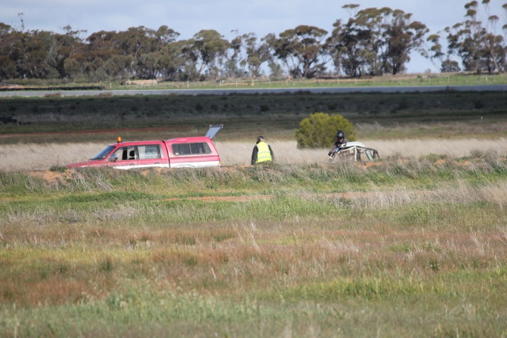But then you spotted the Mercedes in the lineup. Is he *really* going to Autocross that? A few years ago it would have been middle-class executive transport. But here it is. And of course you can’t help but hear Ian Johnston’s blown V8-powered Lexcen; sounds familiar, yes, but back in the era of Badge Engineering neither Holden nor Toyota were building these things with AWD, and what was considered you-beaut engine management gizmotronitry at the time wouldn’t hold a candle to the space-shuttle electronics that run this beast today. Finally sorted and loaded for bear, it doesn’t just spin it’s wheels; it rotates the earth. The fleet of Excels and Lancers mingle with the off-road buggy and the oddball ‘80s Corona Liftback; the Soobys mix it with – of all things – a V6 AWD Magna… and ya gotta love Autocross don’t ya. Bang for your buck it’s gotta be the most fun you can have in a car with your pants on. There is – literally – something for everyone. Whatever floats your boat, add a fire extinguisher and go racing.

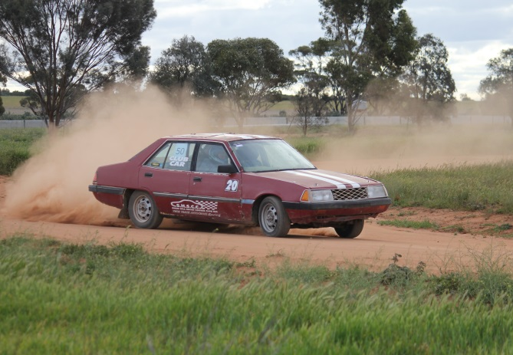Till next month.

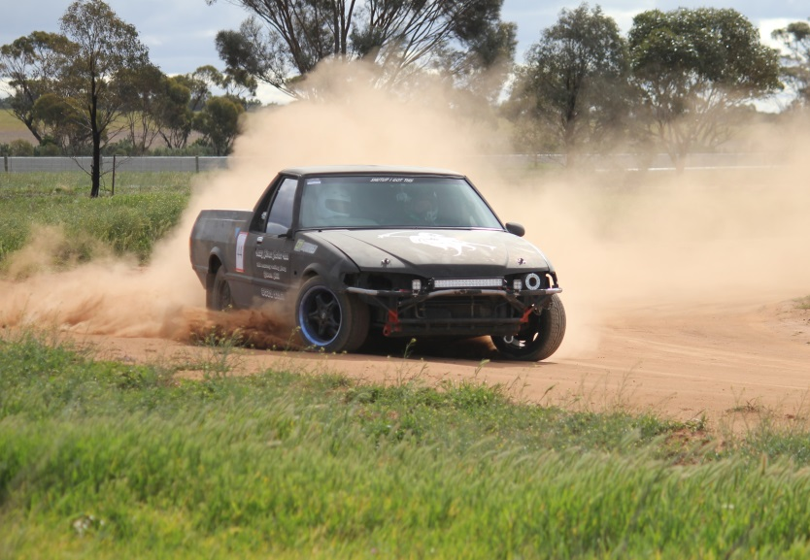

Rob

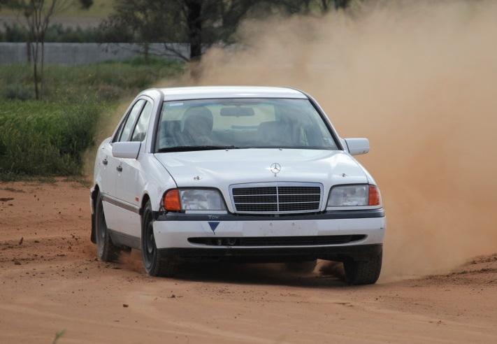

**Prez’s Report**

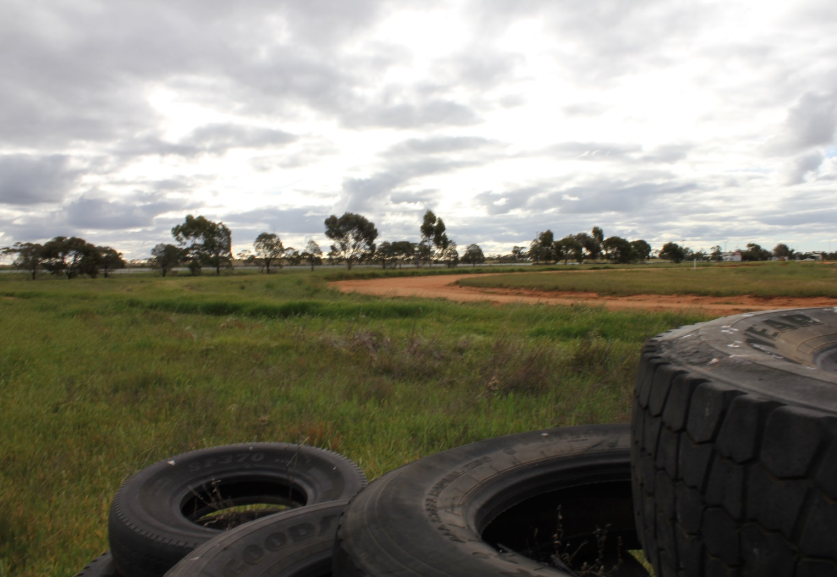Where to start? Monday before the event you could not even walk on the track, let alone race on it, but no more rain, add some wind, do a bit of pumping, some smudging and a roll, then put out your entire stock of cones and you have a race track. Then Wednesday saw a flurry of action with a new computer, the addition of internet and an upgraded Wi-Fi printer, repairs to the bridge safety light, mowing, spraying of weed killer around the edges and of course more pumping and smudging.

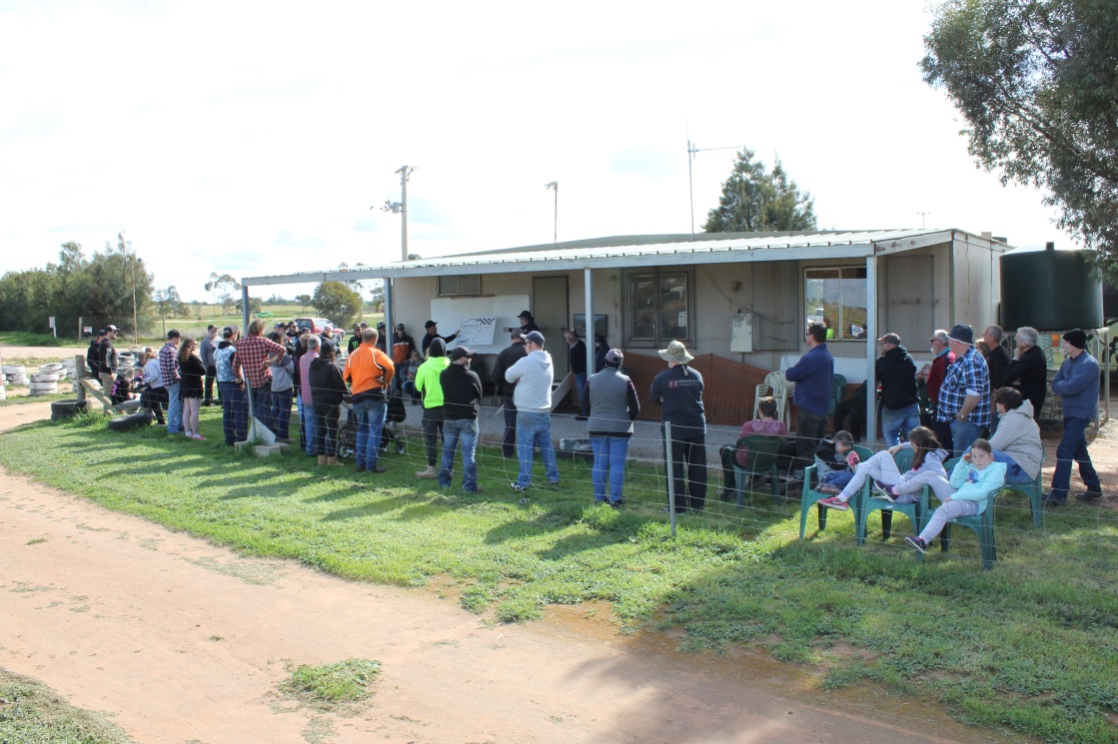Just under ½ the entries came via the Cams portal, and this was a great help at the start of the day as we could pre-enter almost ½ the field of 45 drivers. Scrutineering went well with many hands making light work. The EFTPOS was a hit and well used.

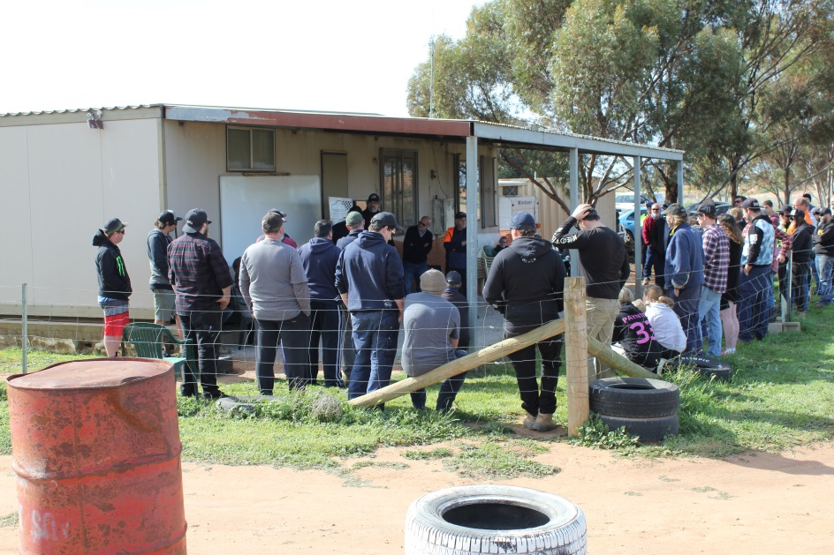But man, I am not sure they make a better weekend - the weather was perfect, the track was fantastic, the people were awesome and we had 2 days of racing; we even pulled off a night run with over 100 starts. In total we had more than 900 starts over the 2 days. By Sunday morning we were doing 125 per hour and by the afternoon we were running out of people to fill the queue.

We gave the pizza idea another run, with $10 a head for any who wanted to partake. We ordered 40 pizzas for tea Saturday night and it was a great hit; we might have underestimated the time it took to eat, but at least it was dark when we got to give the twilight a go.

Saturday saw us run from 1.30pm to 5.30pm, break for tea then have a go at twilight - you have to say have a go because you just do not know if you can do it until you try, as without some wind you cannot see for dust. But after a bit of tuning we found we could release every 110 seconds and it worked quite well, with just over 100 starts in and one and ½ hours. It looked fantastic.

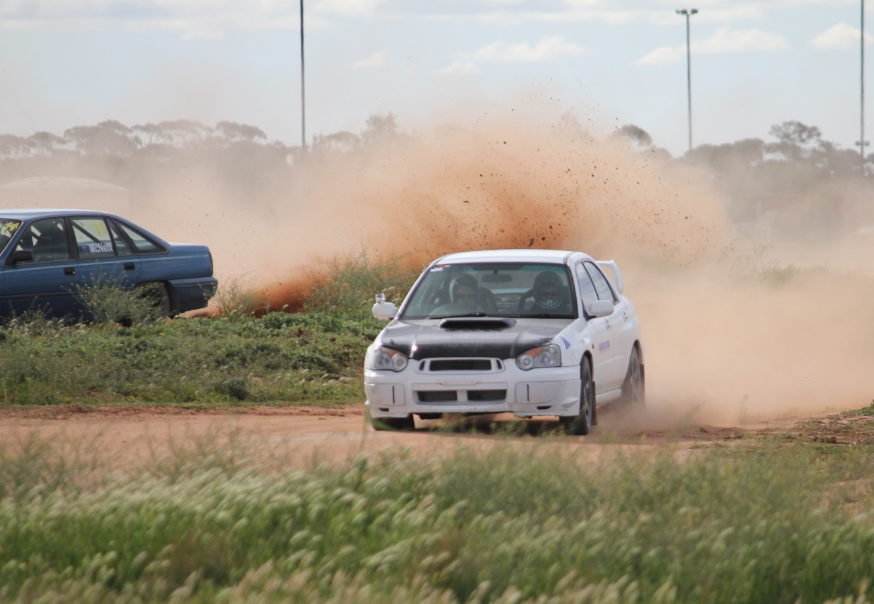Sunday got off at 10.30am and stopped for lunch from 12.30pm to 1.30pm. Most had either run out of fuel or effort by 3.30pm! A brilliant weekend.

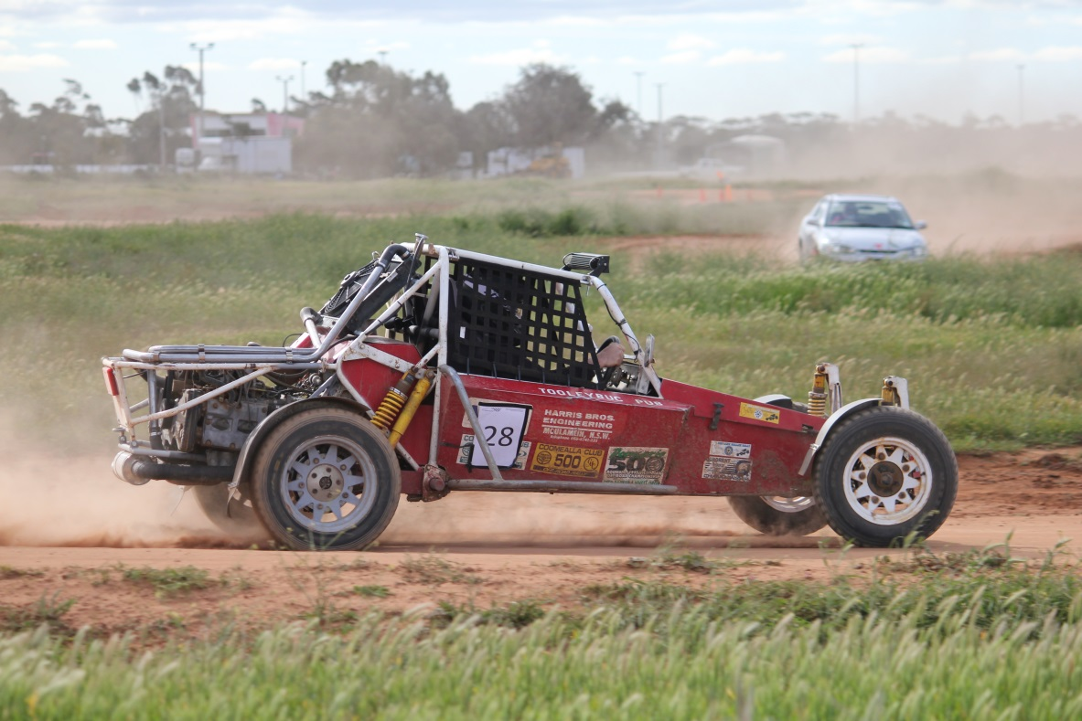Ok, so there was the odd drama - a few engines not as happy as they were Friday, a few tyres that were the same and lots of body parts (cars that is) not looking as flash as they once did (at least one whole car in that category). But gee they must have had a great time, and don’t get me started on cones and tyre walls. A huge thank you to all the people that helped pull this off, and to everyone that chipped in over the weekend. It helps so much to get a hand with things.

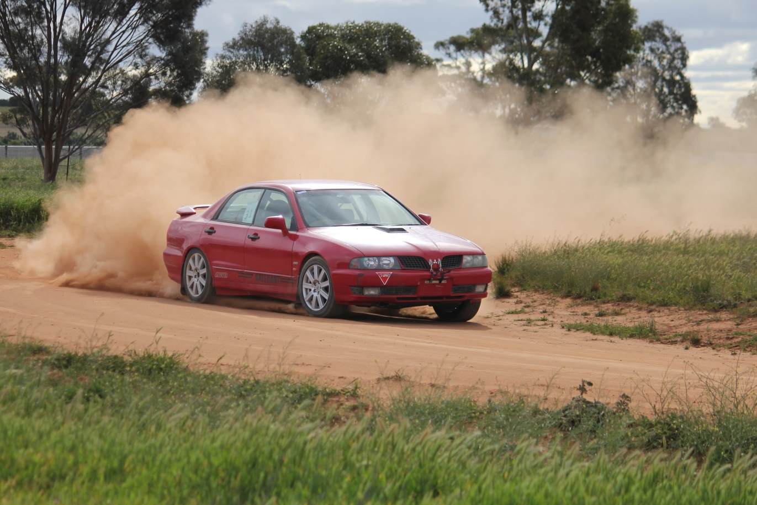Some Standouts of the Weekend.

Most Spectacular would have to go to Glenn King-Gee. It is not often you see a Magna running so wide that it does not just clip the tyre wall but somehow drives along the top of it, although not without wounds -and by the end of the weekend it had plenty, as well as some great results.

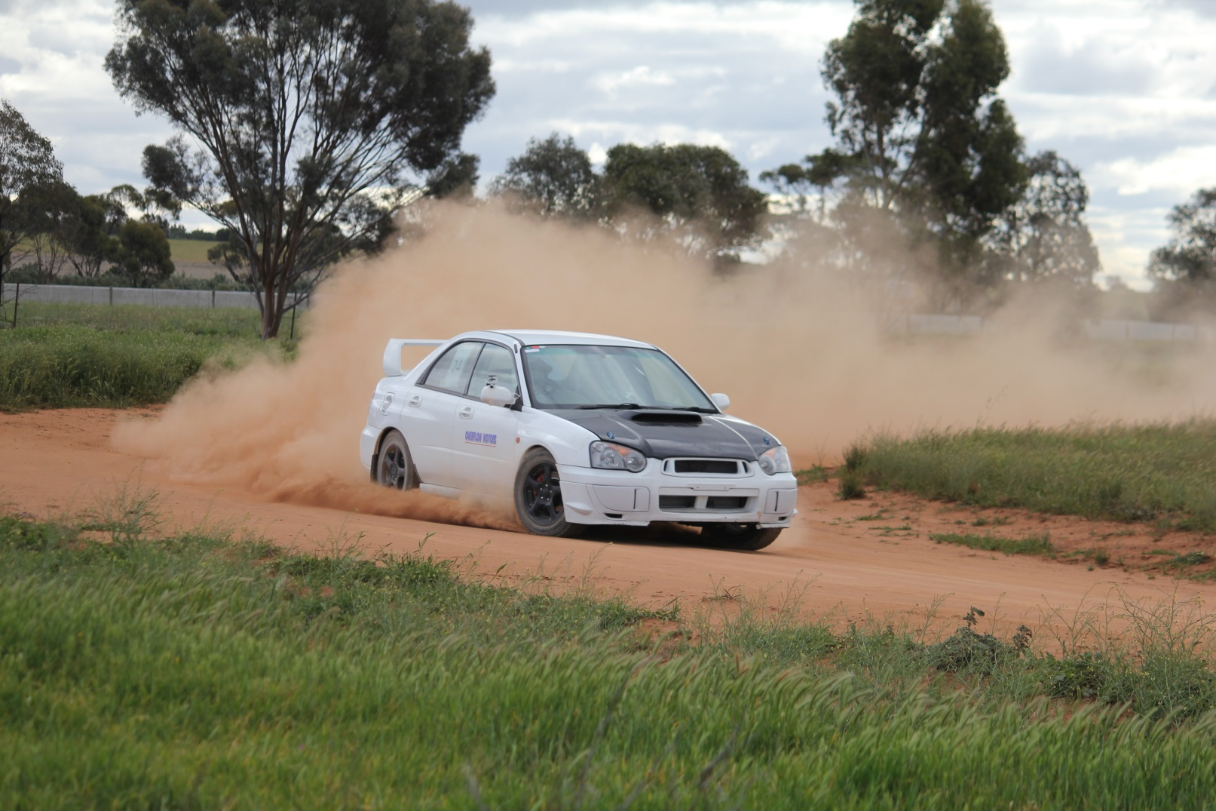Quickest and Tidiest would have to go to Daniel Longford in his rebuilt Subaru WRX, whose weekend was bitter sweet with a bit of engine drama at the end. Hope it is not much of problem for Daniel as he did look the part all weekend.

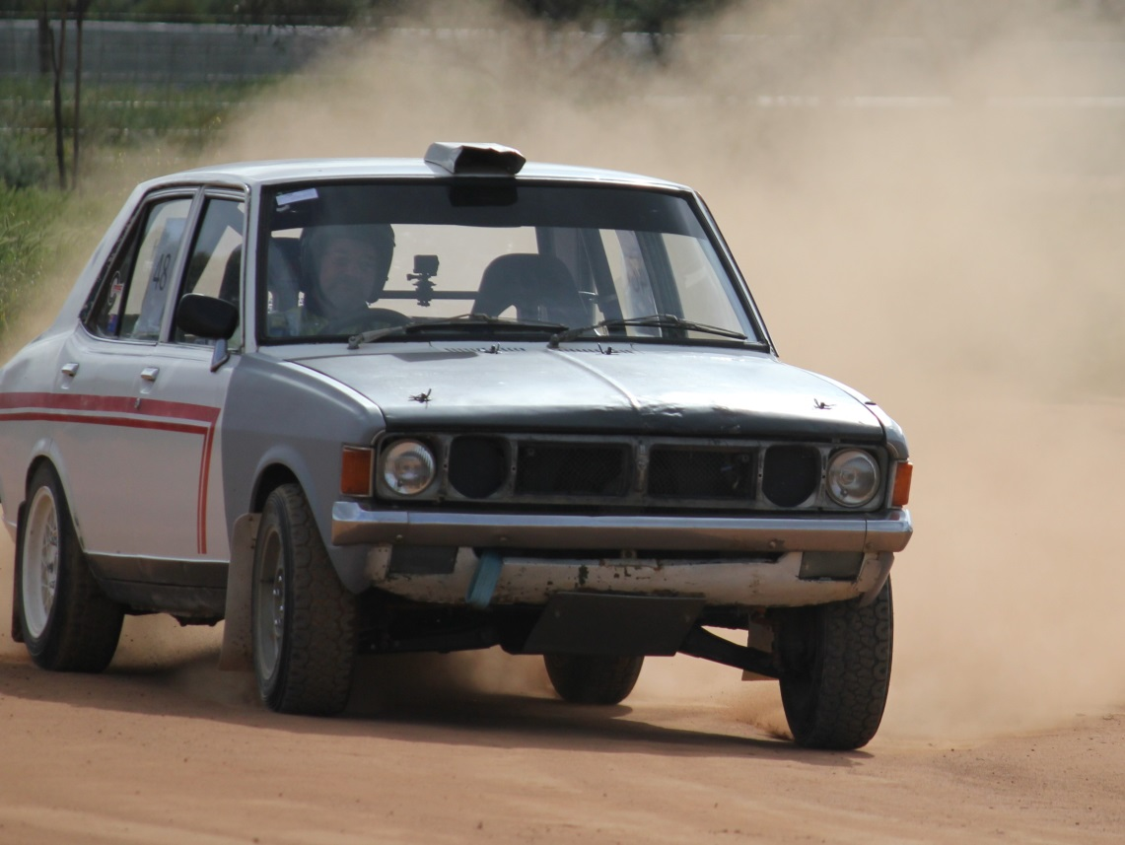Trippy (Kiel Tripcony) brought out his new car for a blast; he used to have a very neat and tidy red Sigma, but has now updated to a white (I hope I am correct) VL Commodore. He was smiling all day and it was great to see him back in action. Anita King-Gee also had some pep in her step, managing a Class J win on Sunday over her good buddy Karli Vallance, whileCraig Williams was having some fun in his new Ute (Ex Mr Dust), which at times looked to be going the same as it used to - sideways everywhere. A lot of fun to watch, and I am sure, to drive.

Reg Johnson also had a great weekend in his Galant and you really do like to hear a nice clean well-tuned engine cross the line. For a non-fuel injected engine it sounded fantastic, clean and crisp not to mention quick, he was flying.

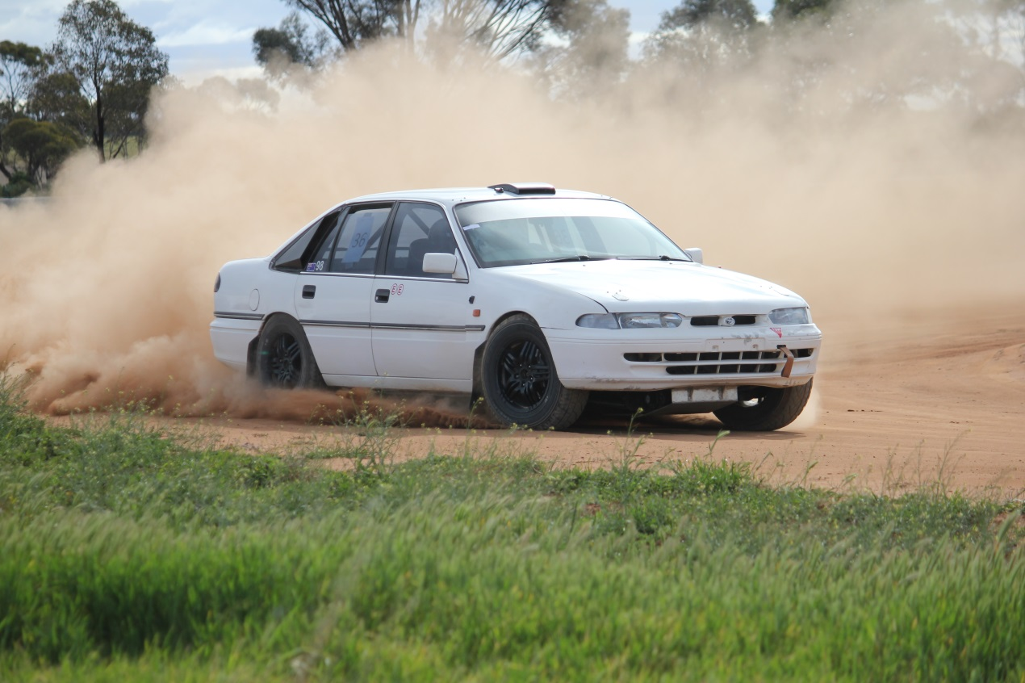Ian Johnston was a very happy camper too, as it seems he has finally sorted out his car (which is one hell of a technological feat in itself). It worked well all weekend and looked the part no matter where it was on the track, and not to mention sounded unreal (Here here! – Ed).

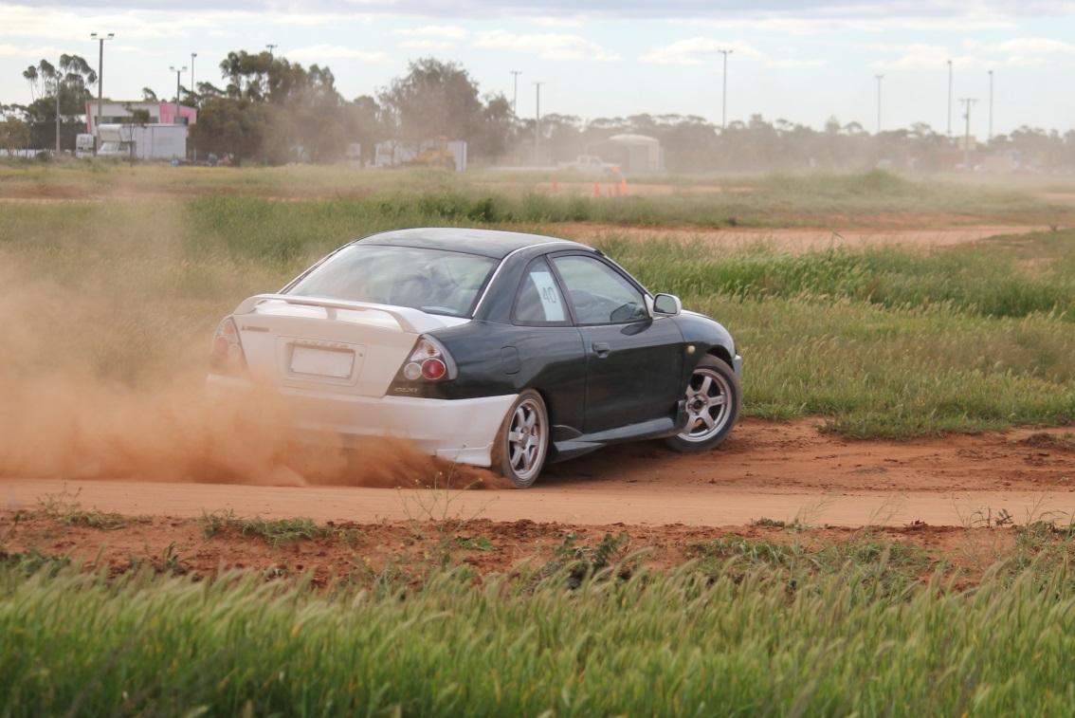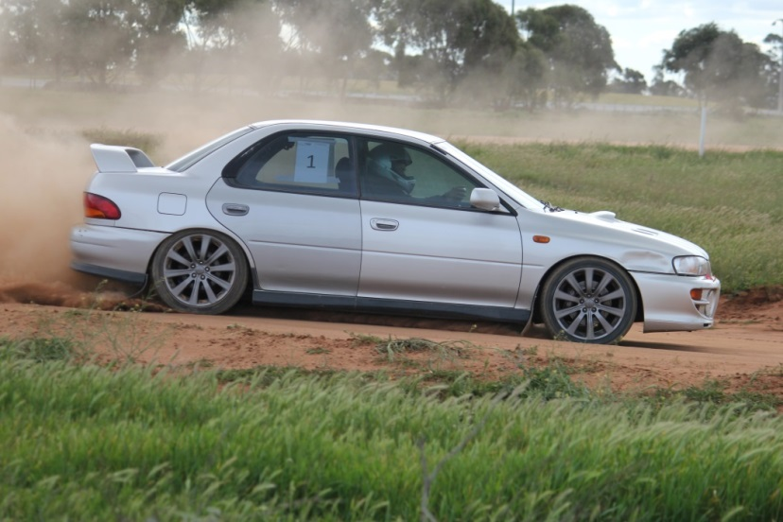There were many other worthy things not mentioned here, including the massive variety of new cars and drivers which was impressive, and lots of new faces which was just awesome to see. It will take a bit to remember all the names.

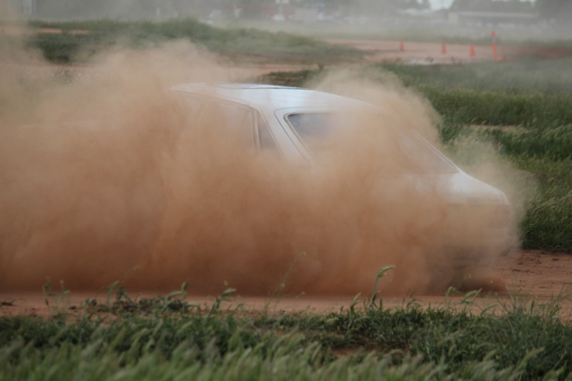

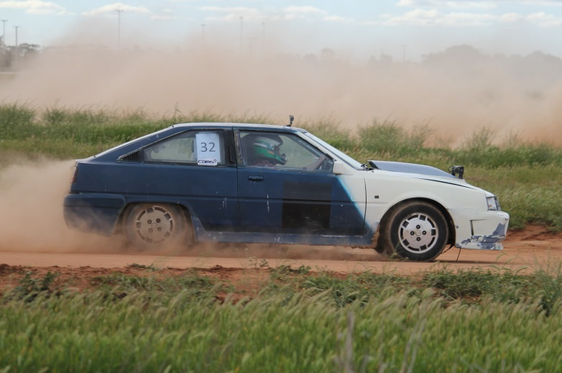

Tips and Tricks.

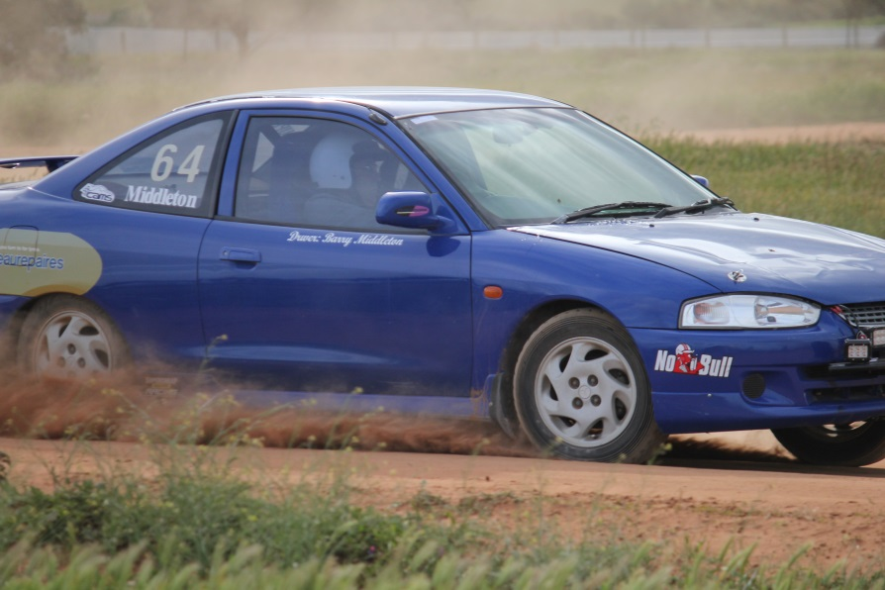Last month I spoke of tubes in your tyres, these are Number One in my book.

This month is about you - get yourself well strapped in. The single largest thing moving around inside the car is you, and through all that movement you are trying to use the steering wheel as something to hang onto rather than a directional control. Now get yourself strapped in well with a racing harness and you are no longer bracing yourself with the wheel, you are just steering the car with it. Your weight swinging around is no longer affecting your steering inputs; you are not getting thrown around as much and can drive much better.

Scrutineering Tip.

Fire extinguishers should be mounted with high tensile bolts. Below is a snippet from Schedule H of the Cams manual which you can find at <http://www.swanhillsportingcarclub.com.au/Tech/default.html>

1. GENERAL

Each automobile in any competition other than non-speed events except where noted in specific Group Regulations or Race meetings must be equipped with a fire extinguisher which complies with the following conditions.

1.1 HAND-HELD FIRE EXTINGUISHERS:

(a) Each hand-held fire extinguisher shall be secured using a metal bracket attached to the automobile with only high tensile bolts or equivalent fasteners and/or sufficient clamp/s and must remain restrained under a deceleration or acceleration of 25G ; and

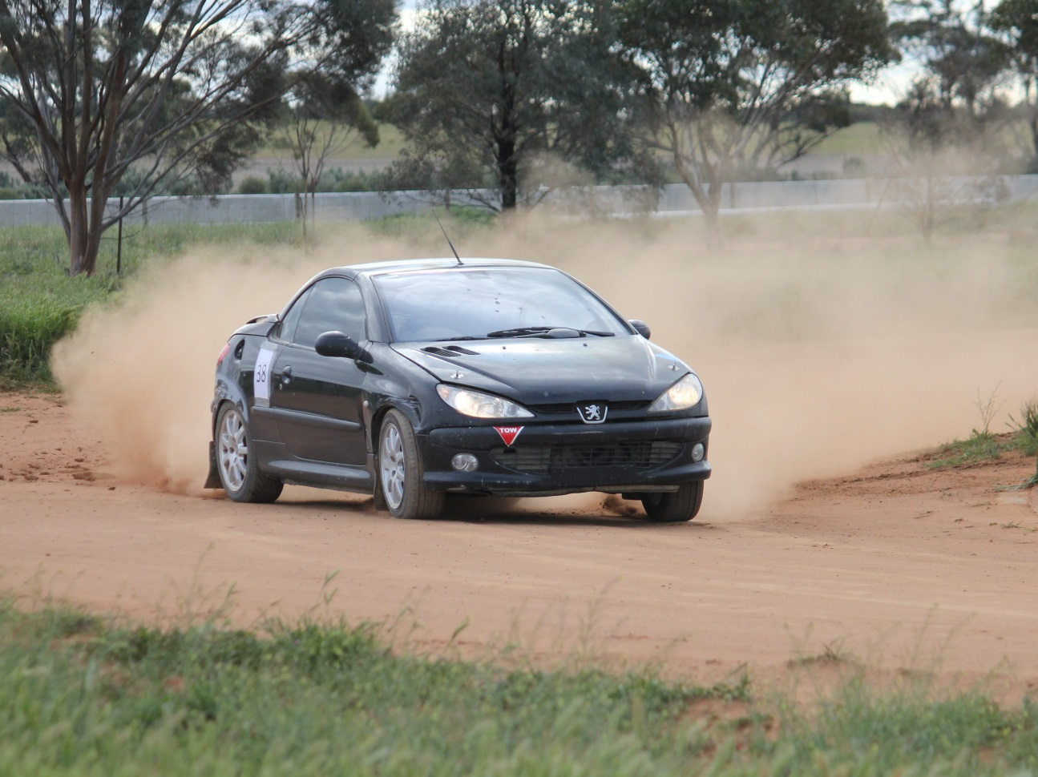(b) must be capable of removal by the driver (or crew, where applicable) while seated in their normal respective position for competition, unless varied by specific category regulations and without the aid of tools.

Saturday by class

Split from class leader in each class



Sunday Overall



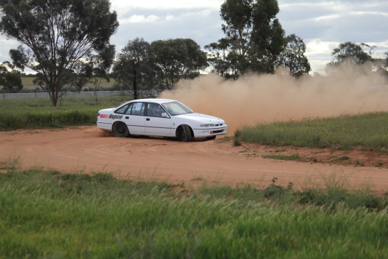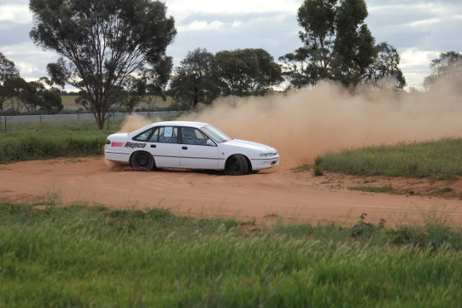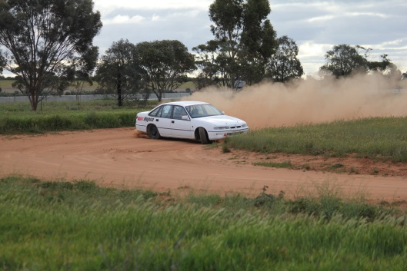

Sunday By Class



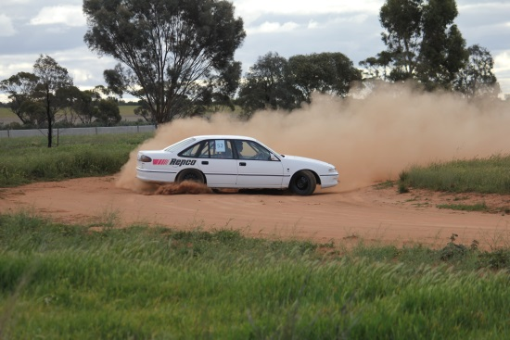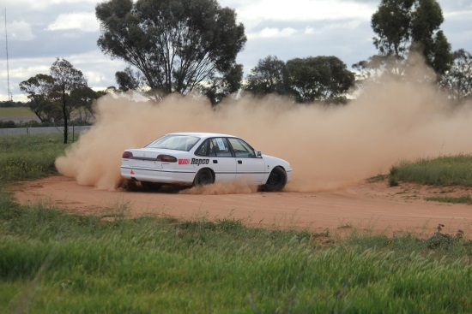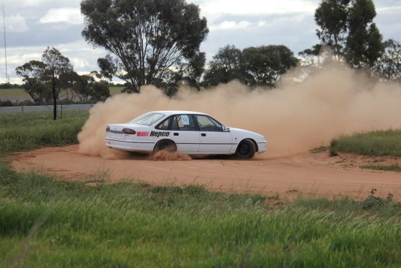

**Working with Children Check**

For anybody filling out the form and needing the postal address of the club it is:

PO Box 691, Swan Hill, Victoria 3585. You can use Club President Chris Gibson’s mobile number as the Phone Contact: 0422036369. [president@swanhillsportingcarclub.com.au](mailto:president@swanhillsportingcarclub.com.au)

This is a copy of an email received via Cams

|  |
| --- |
| Dear all Victorian CAMS Club Representatives, |
|  |
| As some of you may be aware, the Victorian State Government is making amendments to the Working with Children Act 2005 (the Act) that will come into effect on 1 August 2017. These changes require **ALL** Victorians who have 'direct contact' with children to obtain a Working with Children Check (WWCC). **It is important to note that the definition of “direct contact” has expanded** to include:   * Face-to-face contact * Contact by post or other written communication * Contact by telephone or other oral communication * Contact by email or other electronic media.   **References to 'Supervision' have also been removed from the Act**. This means that even if a person’s contact with children as part of their child-related work is supervised by another person, they will still need to apply for a Working with Children Check.   These amendments are being made following a Royal Commission into Institutional Responses to Child Sexual Abuse.    Further information regarding the changes can be found here: [http://www.workingwithchildren.vic.gov.au/home/about+the+check/purpose/changes+to+legislation/](http://a.smartmailpro.com/link/khiksh628/sf2xm04ieq)    CAMS would like to remind clubs of their obligations to ensure all relevant personnel (including committee members) hold a valid Working with Children Check. CAMS will now require that ALL licensed Victorian Officials hold a valid WWCC and recommend that club leaders ensure relevant people within their clubs do the same. It is also more important than ever to ensure that licence checks are run in the lead-up to events.    Existing Officials **will not** be required to present their WWCC on the day of an event, however **if they have not applied for a WWCC by 1 August 2017, their CAMS officiating licence will be put ‘on hold’**. The CAMS licence check system will indicate whether someone has an active licence, hence the importance of checking licences online, pre-event.   Presently these changes only affect Victoria, but CAMS anticipates rolling out this initiative Australia-wide over the next 12 months. CAMS recommend clubs in other States be pro-active and require their staff/volunteers and anyone who has contact with children to obtain a WWCC.  Once approved, details will need to be emailed to [workingwithchildren@cams.com.au](mailto:workingwithchildren@cams.com.au)  The email should include:   * Full name * CAMS licence number * Working with Children Check number/reference * Working with Children Check expiry date * A scanned copy/photograph of the card.     In addition to the FAQs attached, a WWCC will still be required for events where all participants have to be aged over 18.   For those that don’t currently have a check, please follow the link below to begin your application: [http://www.workingwithchildren.vic.gov.au/home/applications/apply+for+a+check/apply+in+victoria](http://a.smartmailpro.com/link/fn38th628/sf2xm04ieq)   When selecting occupational field, volunteers should select Option 42 (clubs, associations or movements of a cultural, recreational or sporting nature).   Any questions regarding these changes can be sent to [workingwithchildren@cams.com.au](mailto:workingwithchildren@cams.com.au). |

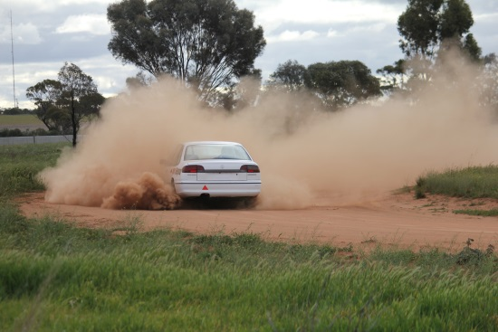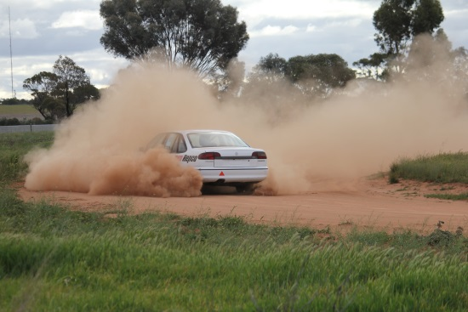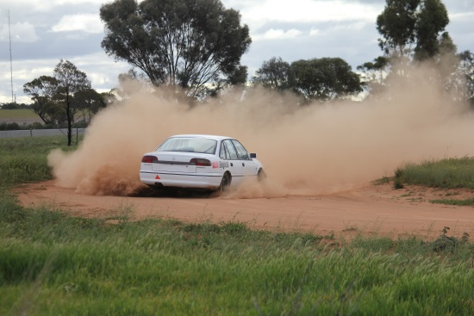

*President:* Chris Gibson [president@swanhillsportingcarclub.com.au](mailto:president@swanhillsportingcarclub.com.au) 0422036369

*Vice President:* Neil Albert [vicepresident@swanhillsportingcarclub.com.au](mailto:vicepresident@swanhillsportingcarclub.com.au) 0408307073

*Secretary/Membership Officer:* Lyn Andrew

[secretary@swanhillsportingcarclub.com.au](mailto:secretary@swanhillsportingcarclub.com.au) 0408378271

*Event Secretary/Licencing Officer:* Lynne Paynter [eventsecretary@swanhillsportingcarclub.com.au](mailto:eventsecretary@swanhillsportingcarclub.com.au)

*Newsletter Editor:* Robert Goff [media@swanhillsportingcarclub.com.au](mailto:media@swanhillsportingcarclub.com.au)

*Club Permit Officer:* Chris Gibson [cps@swanhillsportingcarclub.com.au](mailto:cps@swanhillsportingcarclub.com.au) 0422036369

*Track Manager:* Neil Albert [trackmanager@swanhillsportingcarclub.com.au](mailto:trackmanager@swanhillsportingcarclub.com.au) 0408307073

**NEXT GENERAL MEETING-**

**WEDNESDAY SEPTEMBER 6 - 2017**

**7:30PM**

**LAZY RIVER MOTOR INN.**

Please forward any agenda items to Chris Gibson (President) or Lyn Andrew (Secretary).

**Minutes from last year’s meetings can be found on the club website.**

[www.swanhillsportingcarclub.com.au](http://www.swanhillsportingcarclub.com.au)



The Swan Hill Sporting Car Club will, as of the August meeting, have EFTPOS facilities at the track. You will be able to use EFTPOS to pay race fees and to purchase food at the canteen (please note there is no cash withdrawals). Cards accepted: Visa, Master and Debit/Eftpos cards. Also in today’s paperless world Eftpos receipts can only be emailed if you want a copy.

**Calendar of Events.**

**September 10 SHSCC Test And Tune**

**September 24 VCAS Rd 9, Bendigo**

**October 1 SHSCC Test And Tune**

**October 4 SHSCC General Meeting**

**October 15 VCAS Rd 10, Pakenham**

**Nov ?? Official Invite to DECA Sprint – Date TBC**

**Nov 1 SHSCC General Meeting**

**Nov 5 SHSCC 10 Hour Autocross Regularity Relay – Day 1**

**Nov 6 SHSCC 10 Hour Autocross Regularity Relay – Day 2**

**\*\*\*This Event Subject To CAMS Approval\*\*\***

**Nov 12 VCAS Rd 11, Venue TBC**

**Nov 19 VCAS Rd 12, Geelong**

**Dec 3 SHSCC Test And Tune**

**Dec 6 SHSCC General Meeting**

**Dec 9 SHSCC Club Championship Presentation Night/**

**Christmas Party**

***Not So Random Pics…***

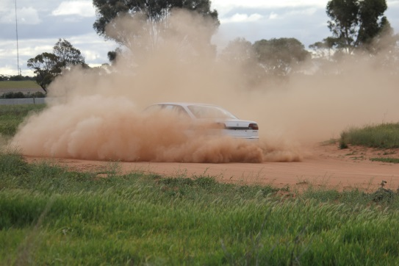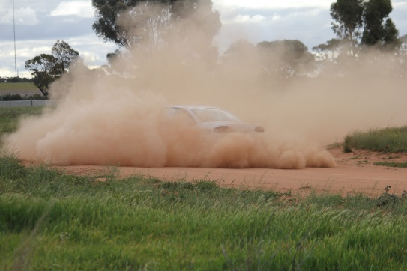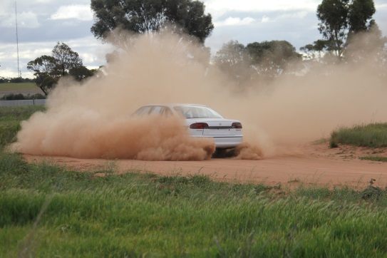

**CLASSES**

In simple terms if it just came off the rood it is **class P**

If you have **done anything** to it and the engine is **below 1600 or 1.6 L it is class C**

If you have **done anything** to it and the engine is **above 1600 or 1.6 L but under 2000 or 2 l it is class D**

If you have **done anything** to it and the engine is **above 2000 or 2l it is class E**

If you are aged from **14 to 18** as of Jan the current year you are **in class J regardless of the car you are driving.**

L Ladies also regardless of car. (Unless it’s Class W)

S Specials (Custom built cars and excessively modified sedans)

W Production Based 4WD or AWD (no tyre restrictions apply)

Below are the more detailed explanations:

**10. CLASSES** (Drivers will be graded into the following classes)

***P***: Standard Production (2WD, Road Tyres Only, No Modifications allowed)

***C***: 0-1600cc Modified (2WD, No Firewall Modifications, Similar Engine Only (Make & No of cyl)

***D***: 1601-2000cc Modified (2WD, No Firewall Modifications, Similar Engine Only (Make & No of cyl)

***E***: Over 2000cc Modified (2WD, No Firewall Modifications, Similar Engine Only (Make & No of cyl)

***J***: Juniors – Aged 14 -18yo as of 1st January 2015

***L***: Ladies

***S***: Specials (Custom built cars and excessively modified sedans)

***W***: Production Based 4WD or AWD (no tyre restrictions apply)

*- Refer the VCAS 2015 Standing Regulations for full details*

When a vehicle is fitted with forced induction the swept displacement shall be multiplied by a factor of 1.7 to determine its nominal capacity.

6.3 When a vehicle is fitted with a rotary [Wankel-type] engine the swept displacement shall be multiplied by a factor of 1.8 to determine its nominal capacity.

6.4 When a vehicle is fitted with a rotary [Wankel-type] engine and forced induction the swept displacement shall be multiplied by a factor of 1.8 x 1.7 = 3.06 to determine its nominal capacity.

**Here are a couple of random items…**

For a non-road-registered series production-based automobile any cable-operated release bonnet mechanism must be disabled and replaced with at least two fasteners which hold the bonnet closed. (Bonnet pins)

Shall display a blue triangle of sides 150mm indicating the location of the battery.

With visible towing points (capable of accepting a 40mm OD cylindrical test object) fitted forward of the front axle and rearwards of the rear axle and capable of towing the automobile on a sealed surface with its wheels locked;

Please go to <http://www.swanhillsportingcarclub.com.au/Tech/default.html> and have a read if you have question great please ask CG or the scrutineers if they do not know they’ll find out for you.

**We Love Our Sponsors**

Meagan from Get Reel Productions has a special offer for club members. A personal profile video where she will attend the track or another location and guarantee a minimum of 2 hours filming focused solely on the individual’s car, driving etc. The completed video is compacted into a 20-45 minute highlight reel complete with music, titles and special effect overlays. Normally priced at $250, Meagan is offering a 50% discount, available to club members for $125. Bookings are essential, please contact Meagan on 0438 615 077 [meagan@getreelproductions.biz](mailto:meagan@getreelproductions.biz)



Head Office – 40 McCallum Street Swan Hill  Victoria 3585

Visiting – (Tiptoe Podiatry) 25 Albert Street Kerang  Victoria 3579

**(03) 5032 4646**

<http://acoustichealth.com.au/>

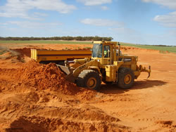

**Contact:** Gary Saville

**Location:** Nyah, Victoria

**Telephone:** 03 5030 2234

**Mobile:**  0427 302 957

**Email:** [gary@coburnsearthmoving.com.au](mailto:gary@coburnsearthmoving.com.au)

<http://www.coburnsearthmoving.com.au>



Coburns Earthmoving specialises in earthmoving and excavations including dam construction, road construction, irrigation, subdivision and general earthworks thoughout Victoria.



Country Tracks 4WD Accessories & Exhaust Centre is located in Swan Hill and is renowned for offering a comprehensive range of accessories from the most credible and respected brands in the industry.  There are accessories for any 4WD vehicle and any type of 4WD user. Customers have the option of having the accessories fitted on the premises, thereby saving them valuable time and money.  14 Chapman Street, Swan Hill VIC 3585(03) 5032 1448 <http://www.countrytracks.com.au/>

****We only use the latest state of the art cameras. We offer a broad range of packages to suit all styles and budgets. Our work speaks for itself, please take the time to look at our sample works provided on [this site](http://www.getreelproductions.biz/).



**[](http://inharmonycounselling.com.au/home)**

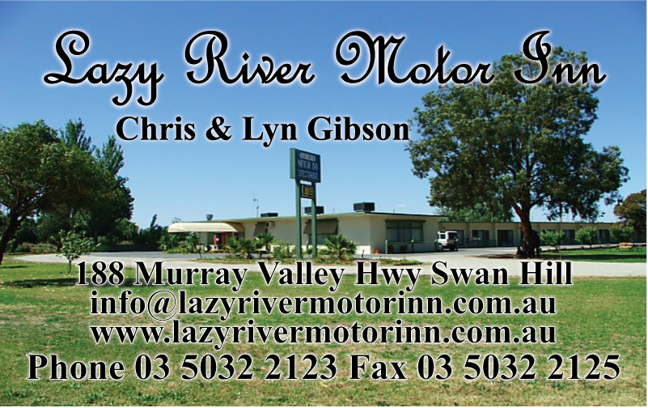

Lazy River Motor Inn with over 2.5 acres and lots of parking. Great for race cars on trailers!!! 188 Murray Valley Hwy Swan Hill Phone Phone 5032 2123 [www.lazyrivermotorinn.com.au](http://www.lazyrivermotorinn.com.au/)

We buy all types of scrap metal in all of Swan Hill, Kerang and the surrounds. Call us and we will come to you.Swan Hill Scrap Metal buy all types of scrap metal, we can pick up from your business, farm or home. All metals including steel, farm machinery, engineering offcuts, data and electrical cable, aluminium, copper, lead batteries, brass or anything metal. Call us and we will do the hard work for you. We are open from Monday to Friday and are available on Saturdays by appointment only. **[](http://swanhillscrapmetal.com/index.html)**(03)503249803Quin Drive Swan Hill



**Lyn Andrew Photography.**

Photos taken at each race event are available for purchase. $20 for copy of all the pictures taken of your car that day with at least 5 edited pics if you supply the USB. $30 for the above if I supply the USB.



**Licence Structure and Pathway**

The Licensing and Accreditation Guide is a reference guide for new and current CAMS Accredited Officials containing information on the National Officiating Program; licence application, upgrade and maintenance; training and development; policies and procedures. Click the link below to download:

[**Licensing and Accreditation Guide 2013-2014** (pdf)](http://docs.cams.com.au/CAMS%20Forms/Officials/Officials%20Resources/Licensing%20and%20Accreditation%20Guide%202013%20vAUG13.pdf)

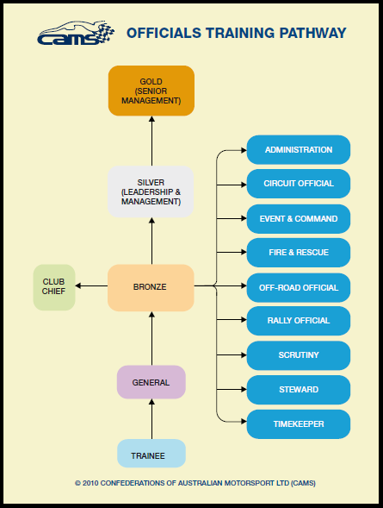 The CAMS Accredited Official licensing structure has two parts: Graded Officials Licences and Non Graded Officials Licences.

Graded Officials Licences have six grading levels and are available to all CAMS Accredited Officials to achieve. Non Graded Officials Licenses have two types: Specialist Licence holders are those that hold professional qualifications and are registered medical service providers. Appointed Licence holders are those that have been appointed by the management of CAMS.

The diagram below shows the licence pathway and the available disciplines in which to specialise at Bronze level. Each of the disciplines in blue have an associated training module, as does General Official (Introductory Module), Club Chief and Silver level. For more information on training modules, visit [Training.](http://www.cams.com.au/get-involved/officials/training)

An official may hold different levels for different disciplines of officiating at any one time (e.g. they could be a Gold Steward and also a Bronze Rally Official). The graded levels are defined as follows:

**Trainee**

For those with no current motor sport officiating experience who are capable of working under direct supervision at all events.

**General Official**

For those with motor sport officiating experience who are capable of working under indirect supervision at all events.

**Club Chief (Club Level Specific)**

For those with motor sport officiating experience working without supervision, capable of performing the role of Clerk of the Course/Event Director, assuming a team-leader role (except Chief Scrutineer) or Chief Steward role at Club/Multi-Club events (excluding race, rally and off road events).

**Bronze**

For those officials qualified to officiate without supervision, capable of performing the role of team-leader (may take responsibility for other officials), officiating as Chief up to and including State level events and act as General Official at any level event.

**Silver**

For those officials with motor sport officiating experience qualified to work without supervision, capable of assuming a team-leader role (and taking responsibility for other officials), officiating as Chief up to and including National level events, and act as a General Official at any level event.

**Gold**

For those officials with motor sport officiating experience qualified to work without supervision, capable of assuming a team-leader role (and taking responsibility for other officials), officiating as Chief up to and including International level events, and act as a General Official at any level event.

Info from <http://www.cams.com.au/get-involved/officials/licence-structure-and-pathway>

**Reminders**

**Race Day Clothing.**

Drivers need to be aware that there are minimum standards for clothing on race day and that clothing standards are part of the scrutineering process. That means that if you are not dressed in your race gear when the car is being scrutineered, then you will have to produce what you are wearing. Below is a summary of what can and cannot be worn when racing. If these standards are not met then you will not pass scrutineering and will not be able to race.

|  |  |
| --- | --- |
| Helmet | Must meet Australian standards. In good condition. No cracks, dents or deep scratches and it cannot be painted. The lining must be in good condition. Fasteners need to be in good condition. |
| Clothing | Drivers and passengers must be dressed in clothing that covers them from neck to ankle to wrists. The clothing can not be nylon. For example, long sleeved Visy tops cannot be worn. |
| Footwear | Footwear can be either shoes or boots. Both need to have a leather upper but can have elastic sides. For example, pull on work boots are ok but nylon sneakers are not. Leather upper sneakers/runners are ok. |

Please follow the link for more in-depth explanation. [CLICK HERE](https://drive.google.com/file/d/0B5lZ_IwrUIFtMzBIbjRYQW5SMFU/edit?usp=sharing)

**Club Apparel.**

Polo Tops, Sweats and Hoodies are now available to order from Blue Sky in Swan Hill with club logo. Please allow adequate amount of time for them to take enough orders to do a run. Prices for the clothing will depend on the size. Logos are available for embroidery on the back (large) and on the front.

**General Official’s Course**- the club needs more Official’s. The first step in the process is to complete a General Official’s Course. Can you please make contact with Lynne Paynter who will advise C.A.M.S. and start the ball rolling.

**Web Site**

Swan Hill Sporting Car Club now has its own web site [www.swanhillsportingcarclub.com.au](http://www.swanhillsportingcarclub.com.au) Please have a look around the site and see what it has to offer. You will notice that there is a forum section. Please register and take part in the forum/s that are of interest to you.