Dusty Digest.

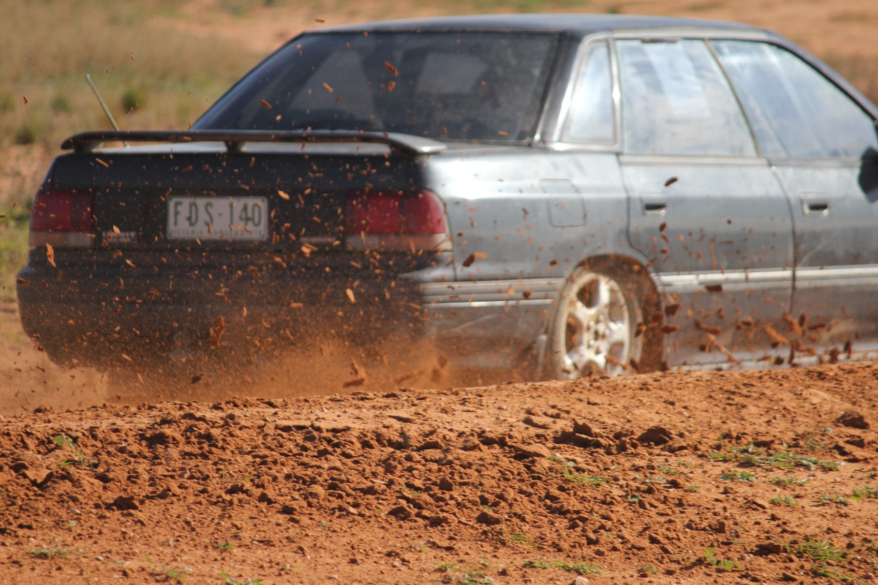

Ed’s Note Pg 2

Prez’s Report Pg 3

Working with Children Checks Pg 6

AGM ReportPg 8

Contacts/Next Meeting Date Pg 9

Event Calendar Pg 10

Tips and Tricks/Random Pics Pg 11

We Love Our Sponsors Pg 14

**Swan Hill Sporting Car Club**

**Newsletter**

**July 2017**

**Editor’s Note**

I’ll apologise in advance for this month’s newsletter. Not only will it be late, and thrown together in one coupla-hours session, there will also be a lot of AGM/WWCC housekeeping in here which is really hard to jazz up and make exciting. Plus Team Goff was actually contributing at the last race meeting for a grand total of about 2 hours and spent the rest of the afternoon in the carpark swearing and waiting for a tow truck (ironic considering neither of us was even racing); therefore our photographic effort was a little lacking – down to about 300 pics this time! Did still score some goals, and I’m proud to say once more I was outshot by Rose, all the good ones this month were hers! That, plus we’ve had the dreaded lurgy for what seems like the last four weeks, the race report was a little light-on, and we bought a house… yep, Actual digs for Gift Horse Racing – and it’s amazing how much else gets totally ignored, shelved or otherwise forgotten about when you’re waiting for your settlement date and watching the bank manager and solicitor fight over what used to be your savings account… but all for a good cause!

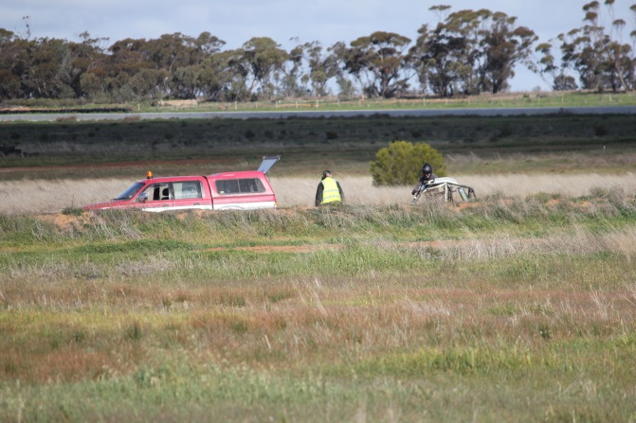Anyway, to cut a long story short, this issue will probably suck. Go back and read the June one again. Will make a better effort for our upcoming Two-Day Event August 12/13. Promise!

Till next month.

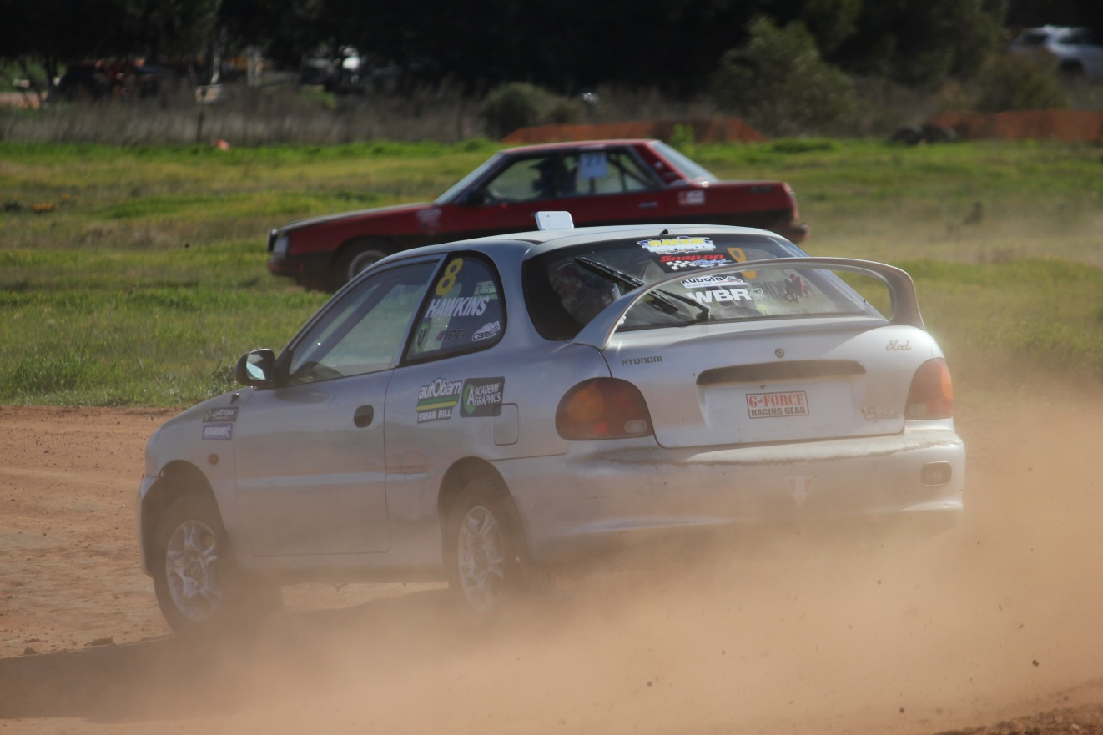

Rob

**Prez’s Report**

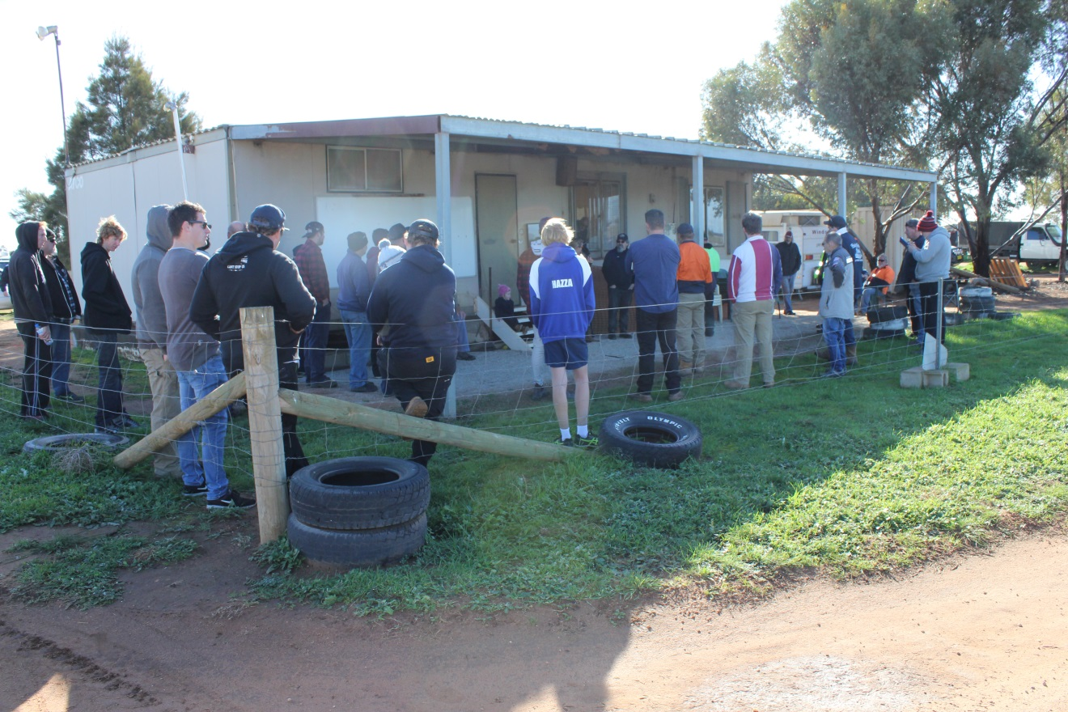It was a top day. The sun was shining - well, occasionally – but of far more importance we were gifted with one of the rarer conditions; just enough moisture in the track surface to make it fast but not wet! This meant almost no dust and heaps of traction. You could hear squealing tyres all around the track and it was easy to see where by following the black patches at the end of the day. Anyone who noticed the amount of water in our dam would realize the track would have been flooded if it was not there – so already the dam is paying off.

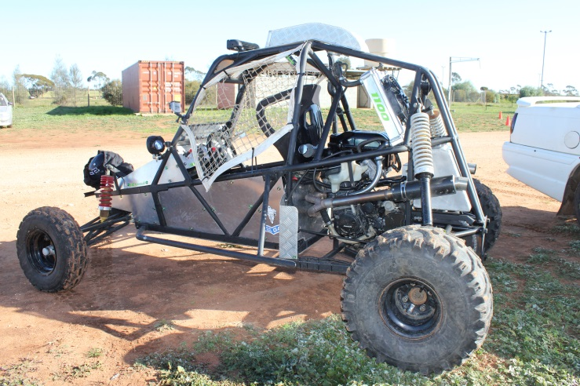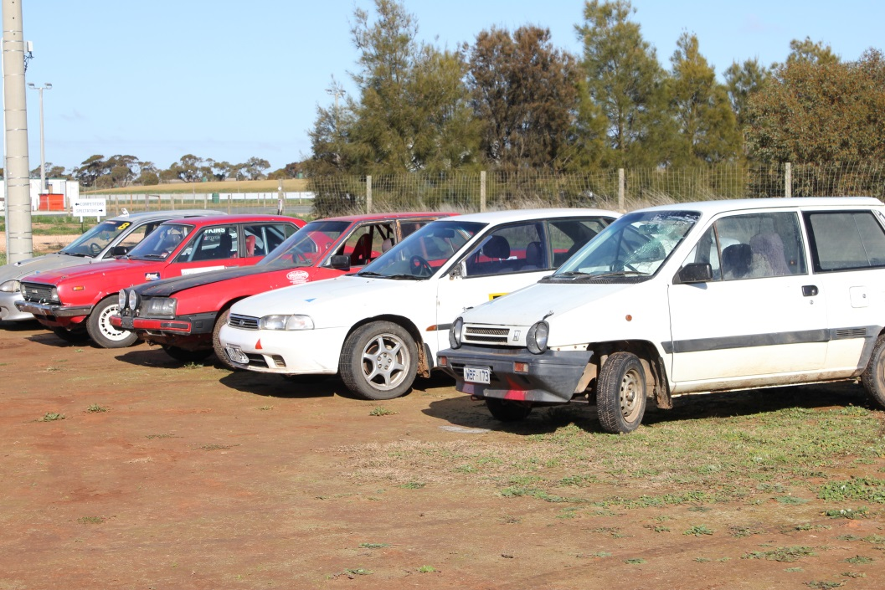Of course traction leads to pace and pace leads to smiles. There were plenty of them, and some great numbers were run throughout the day. Barring a computer mishap which cost the first hour of numbers to be lost, everything ran quite smoothly. Congratulations to the team that ran the day - we do appreciate your help and support. There were also some 40-odd spectators (a total guess) on the fence who got to enjoy the clear viewing conditions. Competitors came from far and wide; Shepparton, Mildura, Wedderburn and Broadford to name a few.

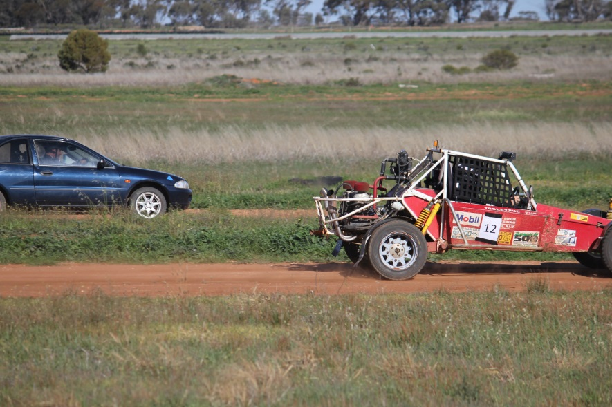It looks like we will still have those awesome track conditions for our next Two-Day Multiclub event on August 12th and 13th.

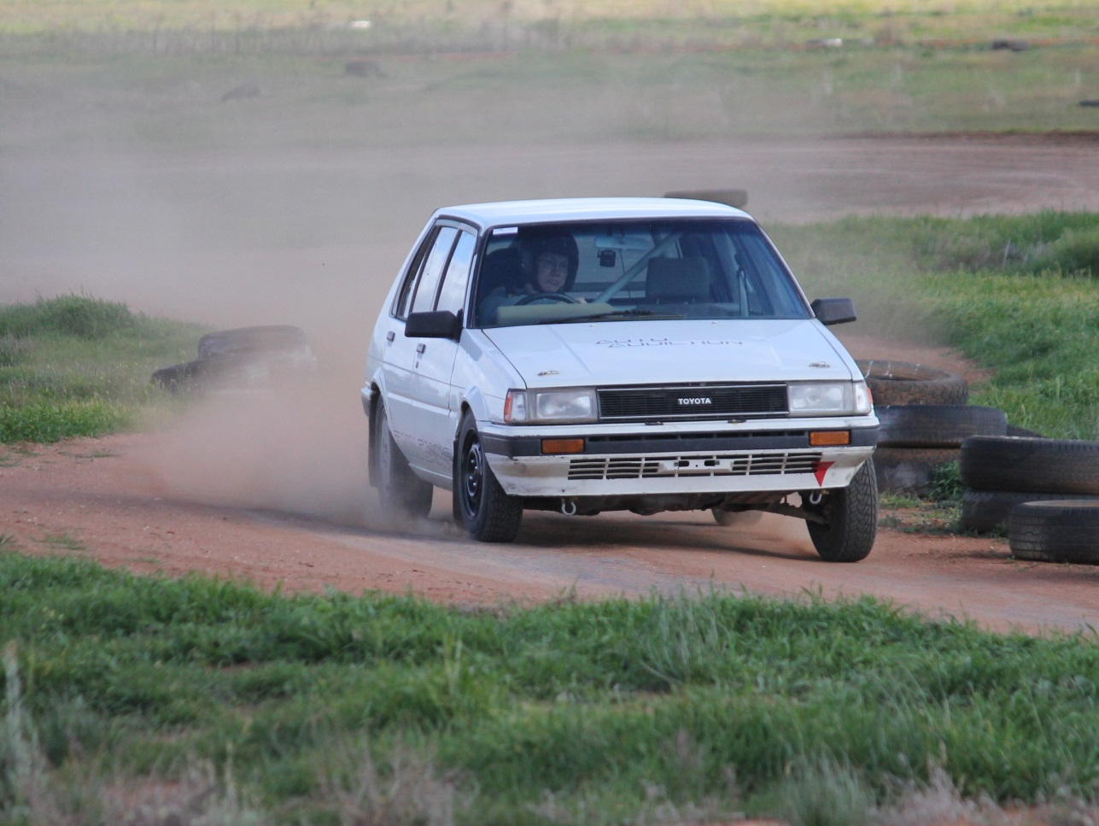**Special Mentions**

Lachlan Melton did extremely well to take out number one overall on the day, both he and Greg Melton looked great in their Corolla making the trip over from Shepparton that little sweeter.

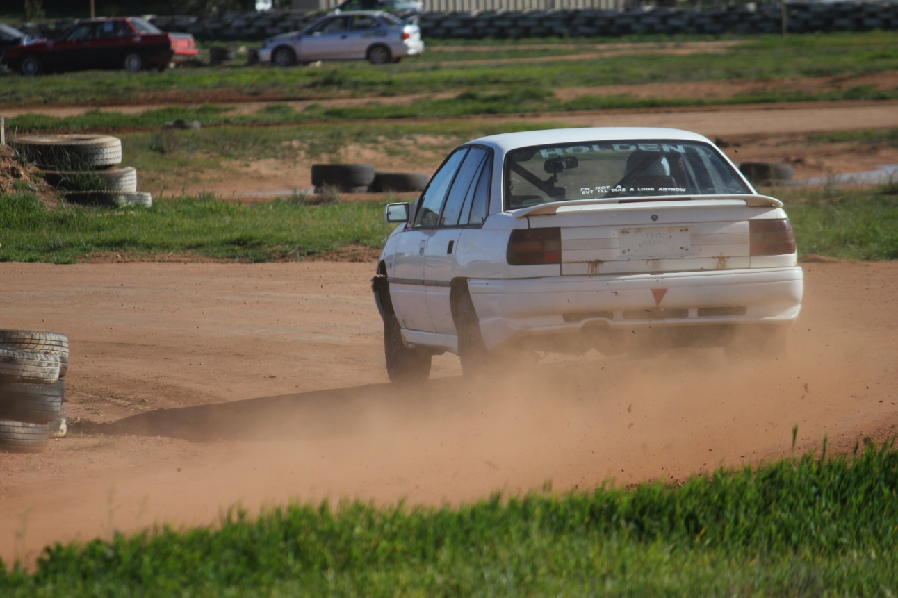Kelvin Jobling, aka Jobbo, also did well in Class E. He was neat all day. I can see some tinkering is paying off.

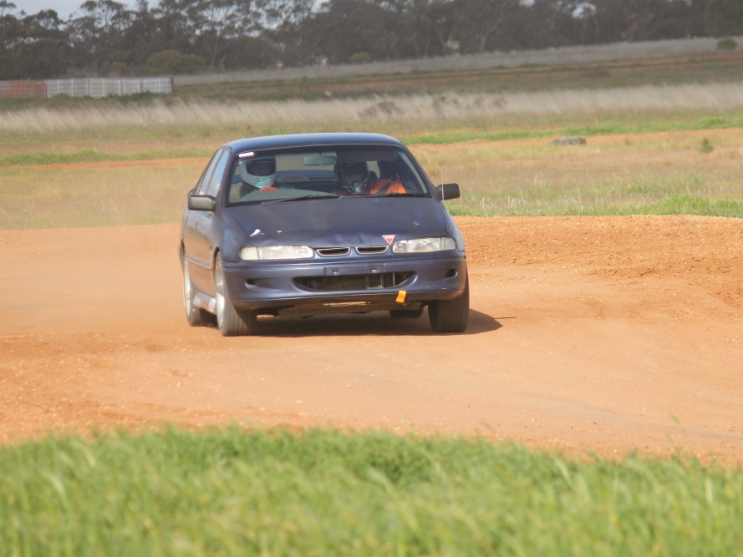Likewise Terrance Ingram put in a good day and was the Class P winner.

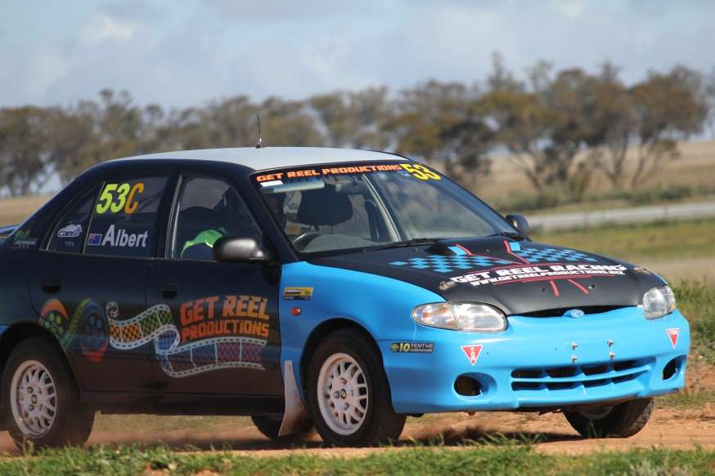

It was good to see our VP Neil Albert get some track time as well with 3rd in Class C. Not always easy when an Official as well.

**Results for each class**

**Overall**

*note we are not allowed to publish direct times of test and tune meeting but we can say Craig William was only just behind Lachlan Melton by 2.61 seconds.

**Working with Children Check**

For anybody filling out the form and needing the postal address of the club it is:

PO Box 691, Swan Hill, Victoria 3585. You can use Club President Chris Gibson’s mobile number as the Phone Contact: 0422036369. [president@swanhillsportingcarclub.com.au](mailto:president@swanhillsportingcarclub.com.au)

This is a copy of an email received via Cams

|  |
| --- |
| Dear all Victorian CAMS Club Representatives, |
|  |
| As some of you may be aware, the Victorian State Government is making amendments to the Working with Children Act 2005 (the Act) that will come into effect on 1 August 2017. These changes require **ALL** Victorians who have 'direct contact' with children to obtain a Working with Children Check (WWCC). **It is important to note that the definition of “direct contact” has expanded** to include:   * Face-to-face contact * Contact by post or other written communication * Contact by telephone or other oral communication * Contact by email or other electronic media.   **References to 'Supervision' have also been removed from the Act**. This means that even if a person’s contact with children as part of their child-related work is supervised by another person, they will still need to apply for a Working with Children Check.   These amendments are being made following a Royal Commission into Institutional Responses to Child Sexual Abuse.    Further information regarding the changes can be found here: [http://www.workingwithchildren.vic.gov.au/home/about+the+check/purpose/changes+to+legislation/](http://a.smartmailpro.com/link/khiksh628/sf2xm04ieq)    CAMS would like to remind clubs of their obligations to ensure all relevant personnel (including committee members) hold a valid Working with Children Check. CAMS will now require that ALL licensed Victorian Officials hold a valid WWCC and recommend that club leaders ensure relevant people within their clubs do the same. It is also more important than ever to ensure that licence checks are run in the lead-up to events.    Existing Officials **will not** be required to present their WWCC on the day of an event, however **if they have not applied for a WWCC by 1 August 2017, their CAMS officiating licence will be put ‘on hold’**. The CAMS licence check system will indicate whether someone has an active licence, hence the importance of checking licences online, pre-event.   Presently these changes only affect Victoria, but CAMS anticipates rolling out this initiative Australia-wide over the next 12 months. CAMS recommend clubs in other States be pro-active and require their staff/volunteers and anyone who has contact with children to obtain a WWCC.  Once approved, details will need to be emailed to [workingwithchildren@cams.com.au](mailto:workingwithchildren@cams.com.au)  The email should include:   * Full name * CAMS licence number * Working with Children Check number/reference * Working with Children Check expiry date * A scanned copy/photograph of the card.     In addition to the FAQs attached, a WWCC will still be required for events where all participants have to be aged over 18.   For those that don’t currently have a check, please follow the link below to begin your application: [http://www.workingwithchildren.vic.gov.au/home/applications/apply+for+a+check/apply+in+victoria](http://a.smartmailpro.com/link/fn38th628/sf2xm04ieq)   When selecting occupational field, volunteers should select Option 42 (clubs, associations or movements of a cultural, recreational or sporting nature).   Any questions regarding these changes can be sent to [workingwithchildren@cams.com.au](mailto:workingwithchildren@cams.com.au). |

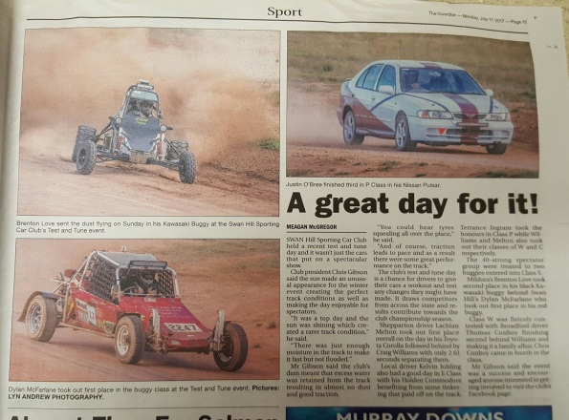

Just in case you missed it

With thanks to Swan Hill Guardian and Lyn Andrew Photography

**AGM**

Our AGM was held on Saturday July the 1st.Thanks to Carolyn & Neil Donnan for hosting, it was a great night with pizza and the odd cocktail. Thanks to the officeholders that stood down for your great help and support of the club and welcome to new people that took up office positions.

President: Chris Gibson     [president@swanhillsportingcarclub.com.au](mailto:president@swanhillsportingcarclub.com.au)       Phone 0422 036 369

Vice President: Neil Albert    [vicepresident@swanhillsportingcarclub.com.au](mailto:vicepresident@swanhillsportingcarclub.com.au)    Phone 0408 307 073

Secretary (membership officer): Lyn Andrew [secretary@swanhillsportingcarclub.com.au](mailto:secretary@swanhillsportingcarclub.com.au)

Phone 0408 378 271

Treasurer: Deb Green.  [treasurer@swanhillsportingcarclub.com.au](mailto:treasurer@swanhillsportingcarclub.com.au)      Phone 0428 526 813

Assistant Treasurer: Ted Paynter [assistanttreasurer@swanhillsportingcarclub.com.au](mailto:assistanttreasurer@swanhillsportingcarclub.com.au)

Phone 0407 365 323

Event Secretary & Licensing Officer: Lynne Paynter [eventsecretary@swanhillsportingcarclub.com.au](mailto:eventsecretary@swanhillsportingcarclub.com.au) Phone 0428 557 512

Assistant Event Secretary: Deb Green. [assistanteventsecretary@swanhillsportingcarclub.com.au](mailto:assistanteventsecretary@swanhillsportingcarclub.com.au)

Publicity Officer: Lyn Andrew  [media@swanhillsportingcarclub.com.au](mailto:media@swanhillsportingcarclub.com.au) Phone 0408 378 271

Newsletter editor: Rob Goff: [news@swanhillsportingcarclub.com.au](mailto:news@swanhillsportingcarclub.com.au) Phone 0415 782 904

Club Permit Officer: Chris Gibson [cps@swanhillsportingcarclub.com.au](mailto:cps@swanhillsportingcarclub.com.au) Phone 0422 036 369

Head Scrutineer: Neil Donnan [chiefscrutineer@swanhillsportingcarclub.com.au](mailto:chiefscrutineer@swanhillsportingcarclub.com.au)  Phone 0428 524 258

Club Car Manager: Glenn King-Gee [clubcarmanager@swanhillsportingcarclub.com.au](mailto:clubcar@swanhillsportingcarclub.com.au) Phone 0428 570 224

Track Manager: Neil Albert    [trackmanager@swanhillsportingcarclub.com.au](mailto:trackmanager@swanhillsportingcarclub.com.au) Phone 0408 307 073

Grants Manager: Chris Gibson and Ted Paynter. [grants@swanhillsportingcarclub.com.au](mailto:grants@swanhillsportingcarclub.com.au)

Welfare officer: Ted Paynter  [welfare@swanhillsportingcarclub.com.au](mailto:welfare@swanhillsportingcarclub.com.au)  Phone 0407 365 323

*President:* Chris Gibson [president@swanhillsportingcarclub.com.au](mailto:president@swanhillsportingcarclub.com.au) 0422036369

*Vice President:* Neil Albert [vicepresident@swanhillsportingcarclub.com.au](mailto:vicepresident@swanhillsportingcarclub.com.au) 0408307073

*Secretary/Membership Officer:* Lyn Andrew

[secretary@swanhillsportingcarclub.com.au](mailto:secretary@swanhillsportingcarclub.com.au) 0408378271

*Event Secretary/Licencing Officer:* Lynne Paynter [eventsecretary@swanhillsportingcarclub.com.au](mailto:eventsecretary@swanhillsportingcarclub.com.au)

*Newsletter Editor:* Robert Goff [media@swanhillsportingcarclub.com.au](mailto:media@swanhillsportingcarclub.com.au)

*Club Permit Officer:* Chris Gibson [cps@swanhillsportingcarclub.com.au](mailto:cps@swanhillsportingcarclub.com.au) 0422036369

*Track Manager:* Neil Albert [trackmanager@swanhillsportingcarclub.com.au](mailto:trackmanager@swanhillsportingcarclub.com.au) 0408307073

**NEXT GENERAL MEETING-**

**WEDNESDAY SEPTEMBER 6 - 2017**

**7:30PM**

**LAZY RIVER MOTOR INN.**

Please forward any agenda items to Chris Gibson (President) or Lyn Andrew (Secretary).

**Minutes from last year’s meetings can be found on the club website.**

[www.swanhillsportingcarclub.com.au](http://www.swanhillsportingcarclub.com.au)

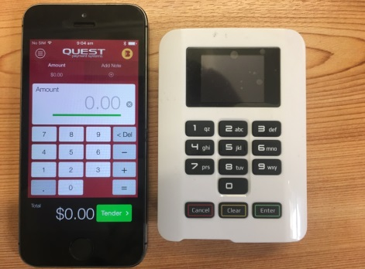

The Swan Hill Sporting Car Club will, as of the August meeting, have EFTPOS facilities at the track. You will be able to use EFTPOS to pay race fees and to purchase food at the canteen (please note there is no cash withdrawals). Cards accepted: Visa, Master and Debit/Eftpos cards. Also in today’s paperless world Eftpos receipts can only be emailed if you want a copy.

**Calendar of Events.**

**August 12 SHSCC Multi-Club Event – Day 1**

**August 13 SHSCC Multi-Club Event – Day 2**

**POSTPONED VCAS Rd 8, Kyneton**

**September 6 SHSCC General Meeting**

**September 10 SHSCC Test And Tune**

**September 24 VCAS Rd 9, Bendigo**

**October 1 SHSCC Test And Tune**

**October 4 SHSCC General Meeting**

**October 15 VCAS Rd 10, Pakenham**

**Nov ?? Official Invite to DECA Sprint – Date TBC**

**Nov 1 SHSCC General Meeting**

**Nov 5 SHSCC 10 Hour Autocross Regularity Relay – Day 1**

**Nov 6 SHSCC 10 Hour Autocross Regularity Relay – Day 2**

**\*\*\*This Event Subject To CAMS Approval\*\*\***

**Nov 12 VCAS Rd 11, Venue TBC**

**Nov 19 VCAS Rd 12, Geelong**

**Dec 3 SHSCC Test And Tune**

**Dec 6 SHSCC General Meeting**

**Dec 9 SHSCC Club Championship Presentation Night/**

**Christmas Party**

**Tips and Tricks**

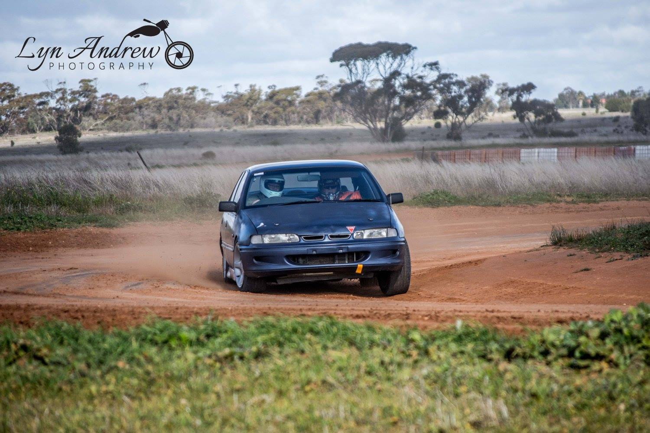I am not in any way picking on anybody here but take a good look at the right front rim, this was a good clear shot of how everyone’s tyres react in a turn when they have load on them. Now in this case the car is on a good clean part of the track but if it was off line a little it would be pushing loose dirt up under the tyre bead, and once it straightened up the tyre will be losing air - sometimes quickly, other times slowly. I cannot emphasize enough the importance of tubes in your tyres, they cost about $100 to have all 4 done but could save your car from a rollover. That is what happens all too often when the tyre goes flat and lets go of the rim.

In the majority of rollovers we have seen at the track there is one tyre flat and off the bead of the rim.

Thanks to Terrence Ingram for a well-placed car and to Lyn Andrew Photography for a great pic. Have a good look at the pics of all your cars, look at tyres, suspension and where the car is on the track. A picture paints a thousand words and you can really learn a lot from a good look at the pics. CG

***Random Pics…***

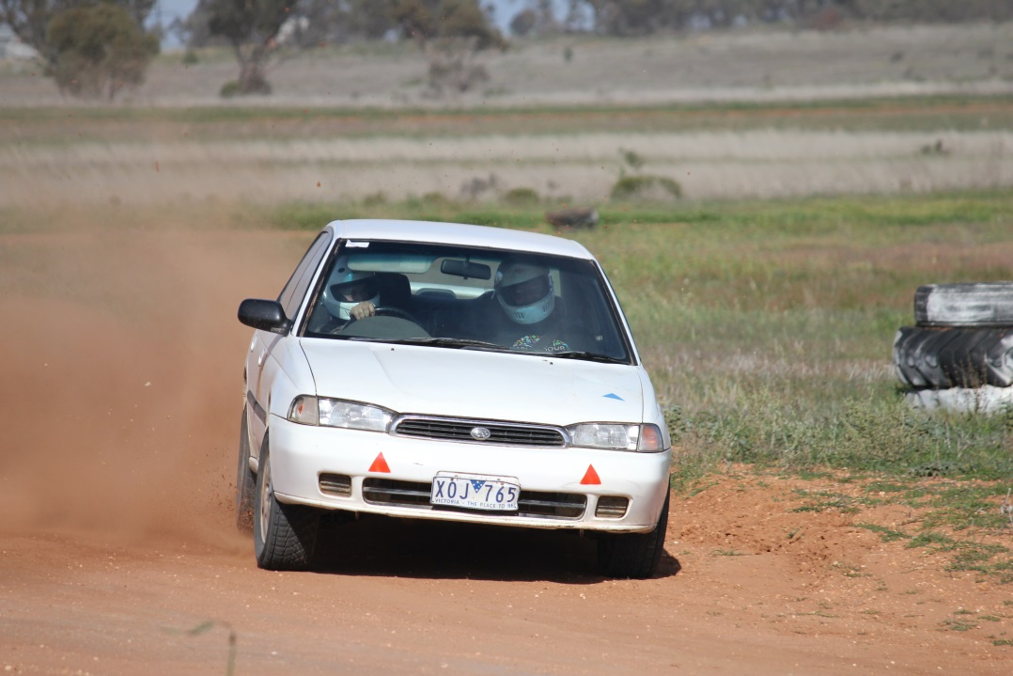

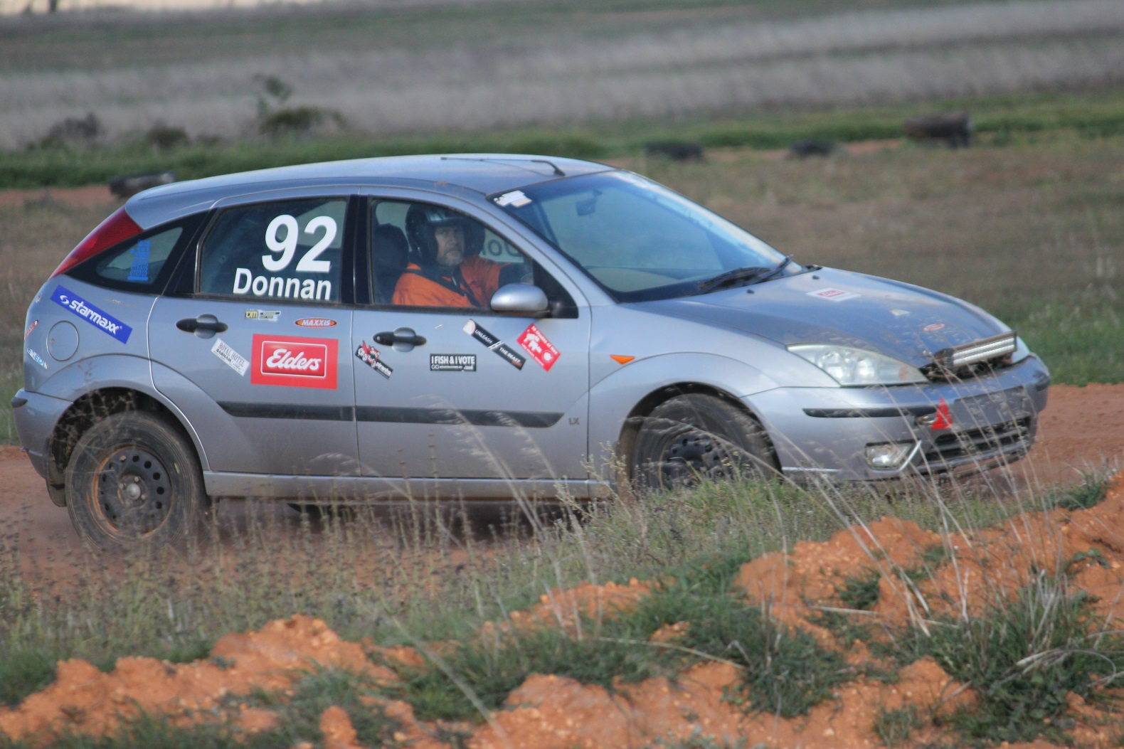

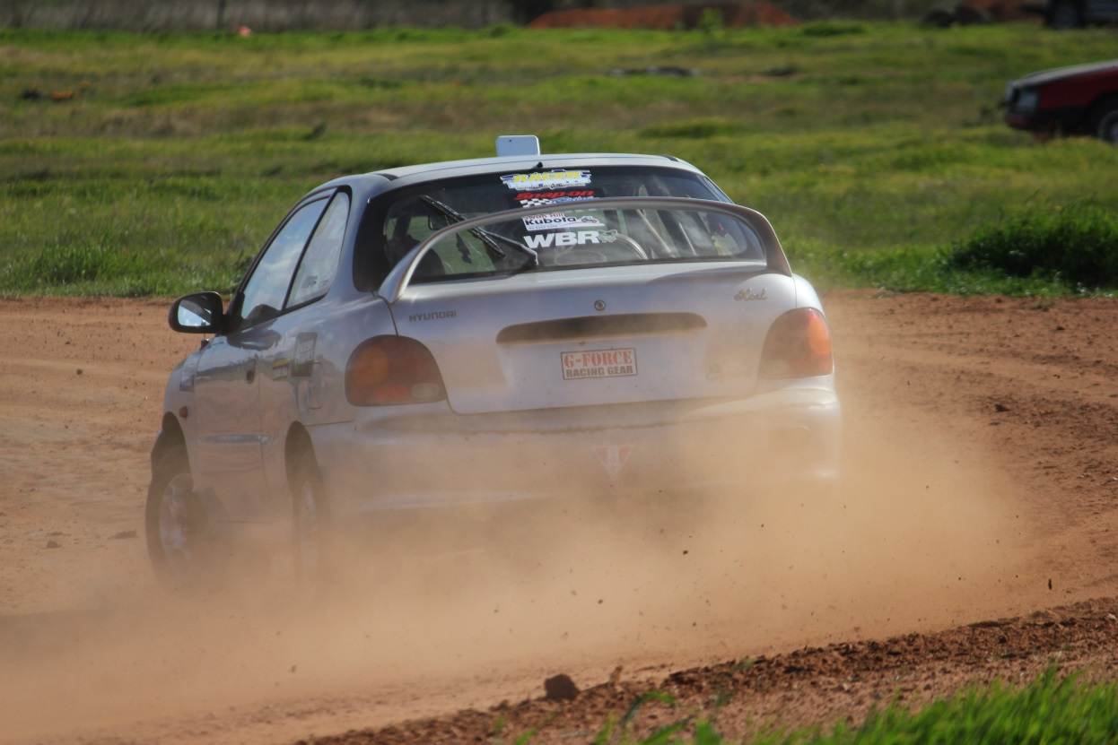

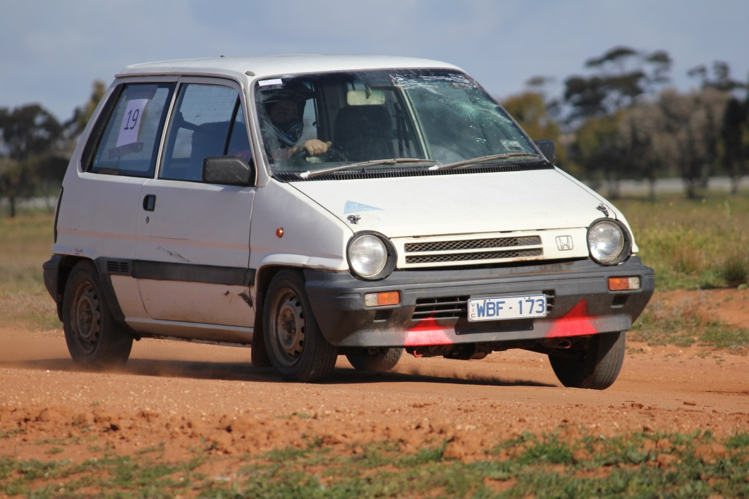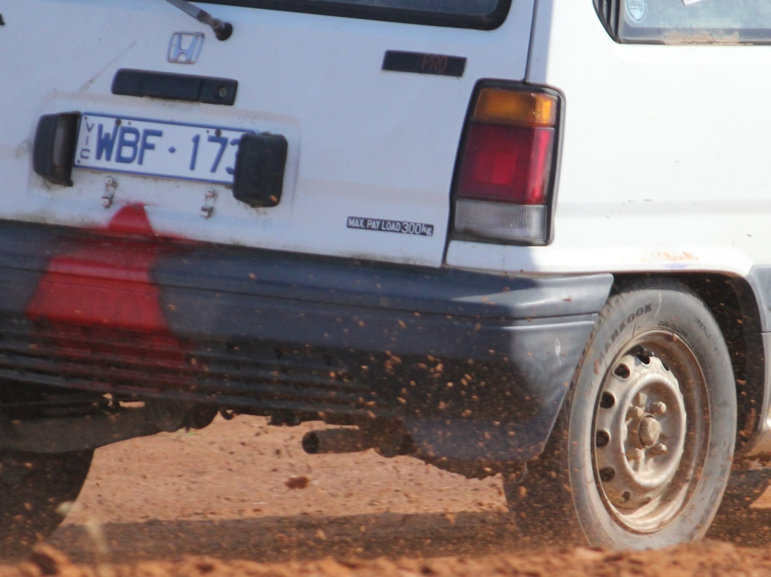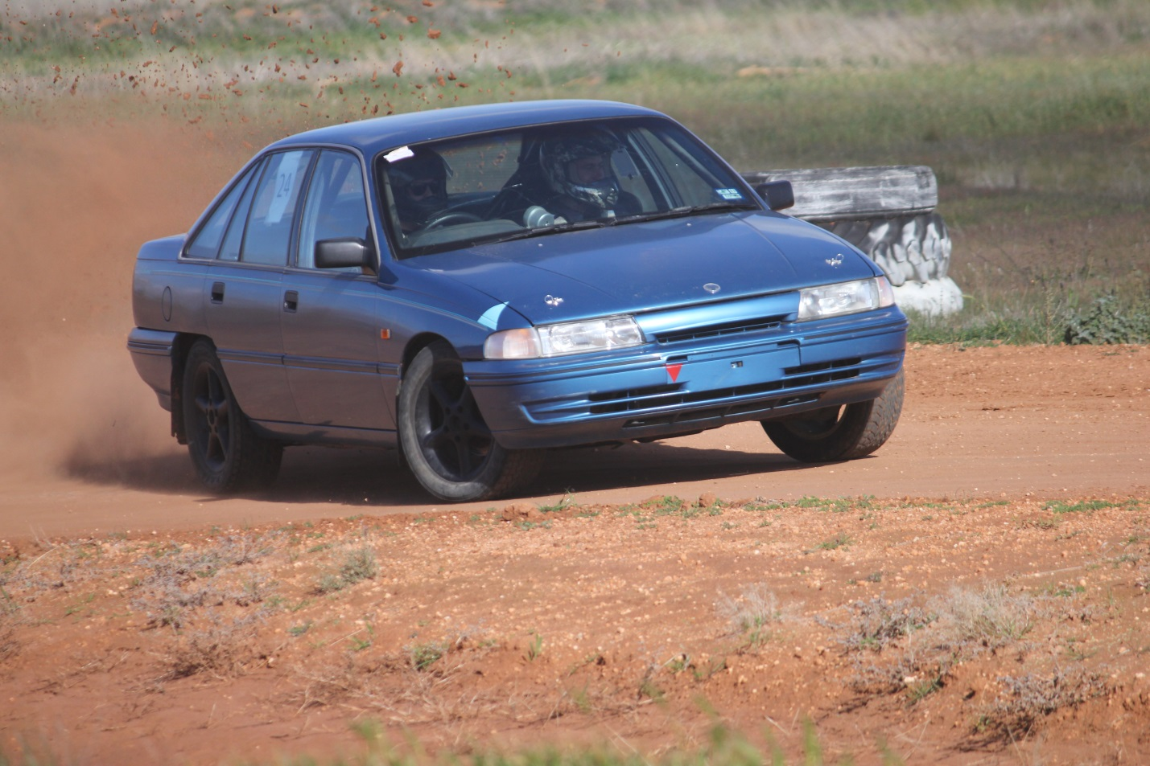

**CLASSES**

In simple terms if it just came off the rood it is **class P**

If you have **done anything** to it and the engine is **below 1600 or 1.6 L it is class C**

If you have **done anything** to it and the engine is **above 1600 or 1.6 L but under 2000 or 2 l it is class D**

If you have **done anything** to it and the engine is **above 2000 or 2l it is class E**

If you are aged from **14 to 18** as of Jan the current year you are **in class J regardless of the car you are driving.**

L Ladies also regardless of car. (Unless it’s Class W)

S Specials (Custom built cars and excessively modified sedans)

W Production Based 4WD or AWD (no tyre restrictions apply)

Below are the more detailed explanations:

**10. CLASSES** (Drivers will be graded into the following classes)

***P***: Standard Production (2WD, Road Tyres Only, No Modifications allowed)

***C***: 0-1600cc Modified (2WD, No Firewall Modifications, Similar Engine Only (Make & No of cyl)

***D***: 1601-2000cc Modified (2WD, No Firewall Modifications, Similar Engine Only (Make & No of cyl)

***E***: Over 2000cc Modified (2WD, No Firewall Modifications, Similar Engine Only (Make & No of cyl)

***J***: Juniors – Aged 14 -18yo as of 1st January 2015

***L***: Ladies

***S***: Specials (Custom built cars and excessively modified sedans)

***W***: Production Based 4WD or AWD (no tyre restrictions apply)

*- Refer the VCAS 2015 Standing Regulations for full details*

When a vehicle is fitted with forced induction the swept displacement shall be multiplied by a factor of 1.7 to determine its nominal capacity.

6.3 When a vehicle is fitted with a rotary [Wankel-type] engine the swept displacement shall be multiplied by a factor of 1.8 to determine its nominal capacity.

6.4 When a vehicle is fitted with a rotary [Wankel-type] engine and forced induction the swept displacement shall be multiplied by a factor of 1.8 x 1.7 = 3.06 to determine its nominal capacity.

**Here are a couple of random items…**

For a non-road-registered series production-based automobile any cable-operated release bonnet mechanism must be disabled and replaced with at least two fasteners which hold the bonnet closed. (Bonnet pins)

Shall display a blue triangle of sides 150mm indicating the location of the battery.

With visible towing points (capable of accepting a 40mm OD cylindrical test object) fitted forward of the front axle and rearwards of the rear axle and capable of towing the automobile on a sealed surface with its wheels locked;

Please go to <http://www.swanhillsportingcarclub.com.au/Tech/default.html> and have a read if you have question great please ask CG or the scrutineers if they do not know they’ll find out for you.

**We Love Our Sponsors**

Meagan from Get Reel Productions has a special offer for club members. A personal profile video where she will attend the track or another location and guarantee a minimum of 2 hours filming focused solely on the individual’s car, driving etc. The completed video is compacted into a 20-45 minute highlight reel complete with music, titles and special effect overlays. Normally priced at $250, Meagan is offering a 50% discount, available to club members for $125. Bookings are essential, please contact Meagan on 0438 615 077 [meagan@getreelproductions.biz](mailto:meagan@getreelproductions.biz)



Head Office – 40 McCallum Street Swan Hill  Victoria 3585

Visiting – (Tiptoe Podiatry) 25 Albert Street Kerang  Victoria 3579

**(03) 5032 4646**

<http://acoustichealth.com.au/>

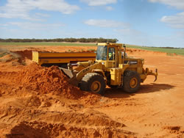

**Contact:** Gary Saville

**Location:** Nyah, Victoria

**Telephone:** 03 5030 2234

**Mobile:**  0427 302 957

**Email:** [gary@coburnsearthmoving.com.au](mailto:gary@coburnsearthmoving.com.au)

<http://www.coburnsearthmoving.com.au>



Coburns Earthmoving specialises in earthmoving and excavations including dam construction, road construction, irrigation, subdivision and general earthworks thoughout Victoria.



Country Tracks 4WD Accessories & Exhaust Centre is located in Swan Hill and is renowned for offering a comprehensive range of accessories from the most credible and respected brands in the industry.  There are accessories for any 4WD vehicle and any type of 4WD user. Customers have the option of having the accessories fitted on the premises, thereby saving them valuable time and money.  14 Chapman Street, Swan Hill VIC 3585(03) 5032 1448 <http://www.countrytracks.com.au/>

****We only use the latest state of the art cameras. We offer a broad range of packages to suit all styles and budgets. Our work speaks for itself, please take the time to look at our sample works provided on [this site](http://www.getreelproductions.biz/).



**[](http://inharmonycounselling.com.au/home)**

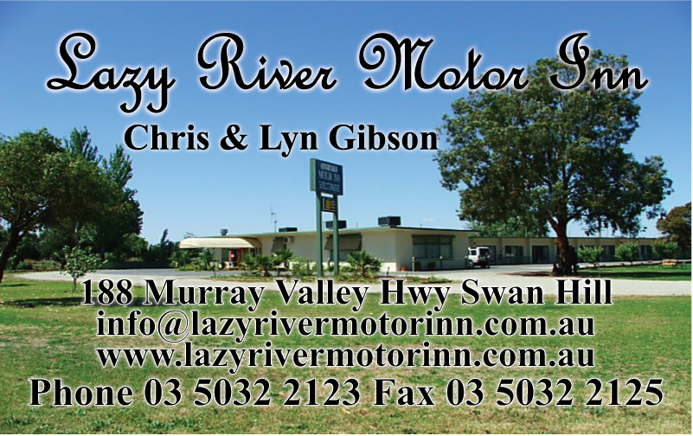

Lazy River Motor Inn with over 2.5 acres and lots of parking. Great for race cars on trailers!!! 188 Murray Valley Hwy Swan Hill Phone Phone 5032 2123 [www.lazyrivermotorinn.com.au](http://www.lazyrivermotorinn.com.au/)

We buy all types of scrap metal in all of Swan Hill, Kerang and the surrounds. Call us and we will come to you.Swan Hill Scrap Metal buy all types of scrap metal, we can pick up from your business, farm or home. All metals including steel, farm machinery, engineering offcuts, data and electrical cable, aluminium, copper, lead batteries, brass or anything metal. Call us and we will do the hard work for you. We are open from Monday to Friday and are available on Saturdays by appointment only. **[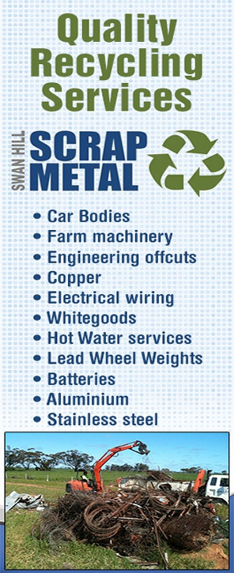](http://swanhillscrapmetal.com/index.html)**(03)503249803Quin Drive Swan Hill



**Lyn Andrew Photography.**

Photos taken at each race event are available for purchase. $20 for copy of all the pictures taken of your car that day with at least 5 edited pics if you supply the USB. $30 for the above if I supply the USB.



**Licence Structure and Pathway**

The Licensing and Accreditation Guide is a reference guide for new and current CAMS Accredited Officials containing information on the National Officiating Program; licence application, upgrade and maintenance; training and development; policies and procedures. Click the link below to download:

[**Licensing and Accreditation Guide 2013-2014** (pdf)](http://docs.cams.com.au/CAMS%20Forms/Officials/Officials%20Resources/Licensing%20and%20Accreditation%20Guide%202013%20vAUG13.pdf)

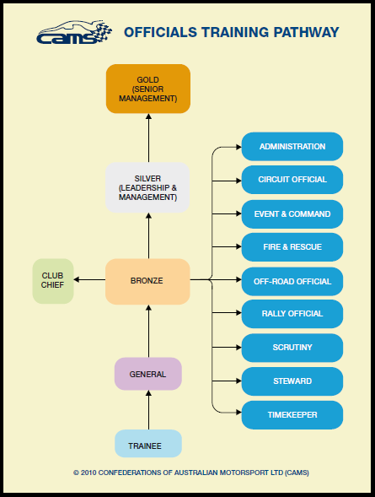 The CAMS Accredited Official licensing structure has two parts: Graded Officials Licences and Non Graded Officials Licences.

Graded Officials Licences have six grading levels and are available to all CAMS Accredited Officials to achieve. Non Graded Officials Licenses have two types: Specialist Licence holders are those that hold professional qualifications and are registered medical service providers. Appointed Licence holders are those that have been appointed by the management of CAMS.

The diagram below shows the licence pathway and the available disciplines in which to specialise at Bronze level. Each of the disciplines in blue have an associated training module, as does General Official (Introductory Module), Club Chief and Silver level. For more information on training modules, visit [Training.](http://www.cams.com.au/get-involved/officials/training)

An official may hold different levels for different disciplines of officiating at any one time (e.g. they could be a Gold Steward and also a Bronze Rally Official). The graded levels are defined as follows:

**Trainee**

For those with no current motor sport officiating experience who are capable of working under direct supervision at all events.

**General Official**

For those with motor sport officiating experience who are capable of working under indirect supervision at all events.

**Club Chief (Club Level Specific)**

For those with motor sport officiating experience working without supervision, capable of performing the role of Clerk of the Course/Event Director, assuming a team-leader role (except Chief Scrutineer) or Chief Steward role at Club/Multi-Club events (excluding race, rally and off road events).

**Bronze**

For those officials qualified to officiate without supervision, capable of performing the role of team-leader (may take responsibility for other officials), officiating as Chief up to and including State level events and act as General Official at any level event.

**Silver**

For those officials with motor sport officiating experience qualified to work without supervision, capable of assuming a team-leader role (and taking responsibility for other officials), officiating as Chief up to and including National level events, and act as a General Official at any level event.

**Gold**

For those officials with motor sport officiating experience qualified to work without supervision, capable of assuming a team-leader role (and taking responsibility for other officials), officiating as Chief up to and including International level events, and act as a General Official at any level event.

Info from <http://www.cams.com.au/get-involved/officials/licence-structure-and-pathway>

**Reminders**

**Race Day Clothing.**

Drivers need to be aware that there are minimum standards for clothing on race day and that clothing standards are part of the scrutineering process. That means that if you are not dressed in your race gear when the car is being scrutineered, then you will have to produce what you are wearing. Below is a summary of what can and cannot be worn when racing. If these standards are not met then you will not pass scrutineering and will not be able to race.

|  |  |
| --- | --- |
| Helmet | Must meet Australian standards. In good condition. No cracks, dents or deep scratches and it cannot be painted. The lining must be in good condition. Fasteners need to be in good condition. |
| Clothing | Drivers and passengers must be dressed in clothing that covers them from neck to ankle to wrists. The clothing can not be nylon. For example, long sleeved Visy tops cannot be worn. |
| Footwear | Footwear can be either shoes or boots. Both need to have a leather upper but can have elastic sides. For example, pull on work boots are ok but nylon sneakers are not. Leather upper sneakers/runners are ok. |

Please follow the link for more in-depth explanation. [CLICK HERE](https://drive.google.com/file/d/0B5lZ_IwrUIFtMzBIbjRYQW5SMFU/edit?usp=sharing)

**Club Apparel.**

Polo Tops, Sweats and Hoodies are now available to order from Blue Sky in Swan Hill with club logo. Please allow adequate amount of time for them to take enough orders to do a run. Prices for the clothing will depend on the size. Logos are available for embroidery on the back (large) and on the front.

**General Official’s Course**- the club needs more Official’s. The first step in the process is to complete a General Official’s Course. Can you please make contact with Lynne Paynter who will advise C.A.M.S. and start the ball rolling.

**Web Site**

Swan Hill Sporting Car Club now has its own web site [www.swanhillsportingcarclub.com.au](http://www.swanhillsportingcarclub.com.au) Please have a look around the site and see what it has to offer. You will notice that there is a forum section. Please register and take part in the forum/s that are of interest to you.