Dusty Digest.

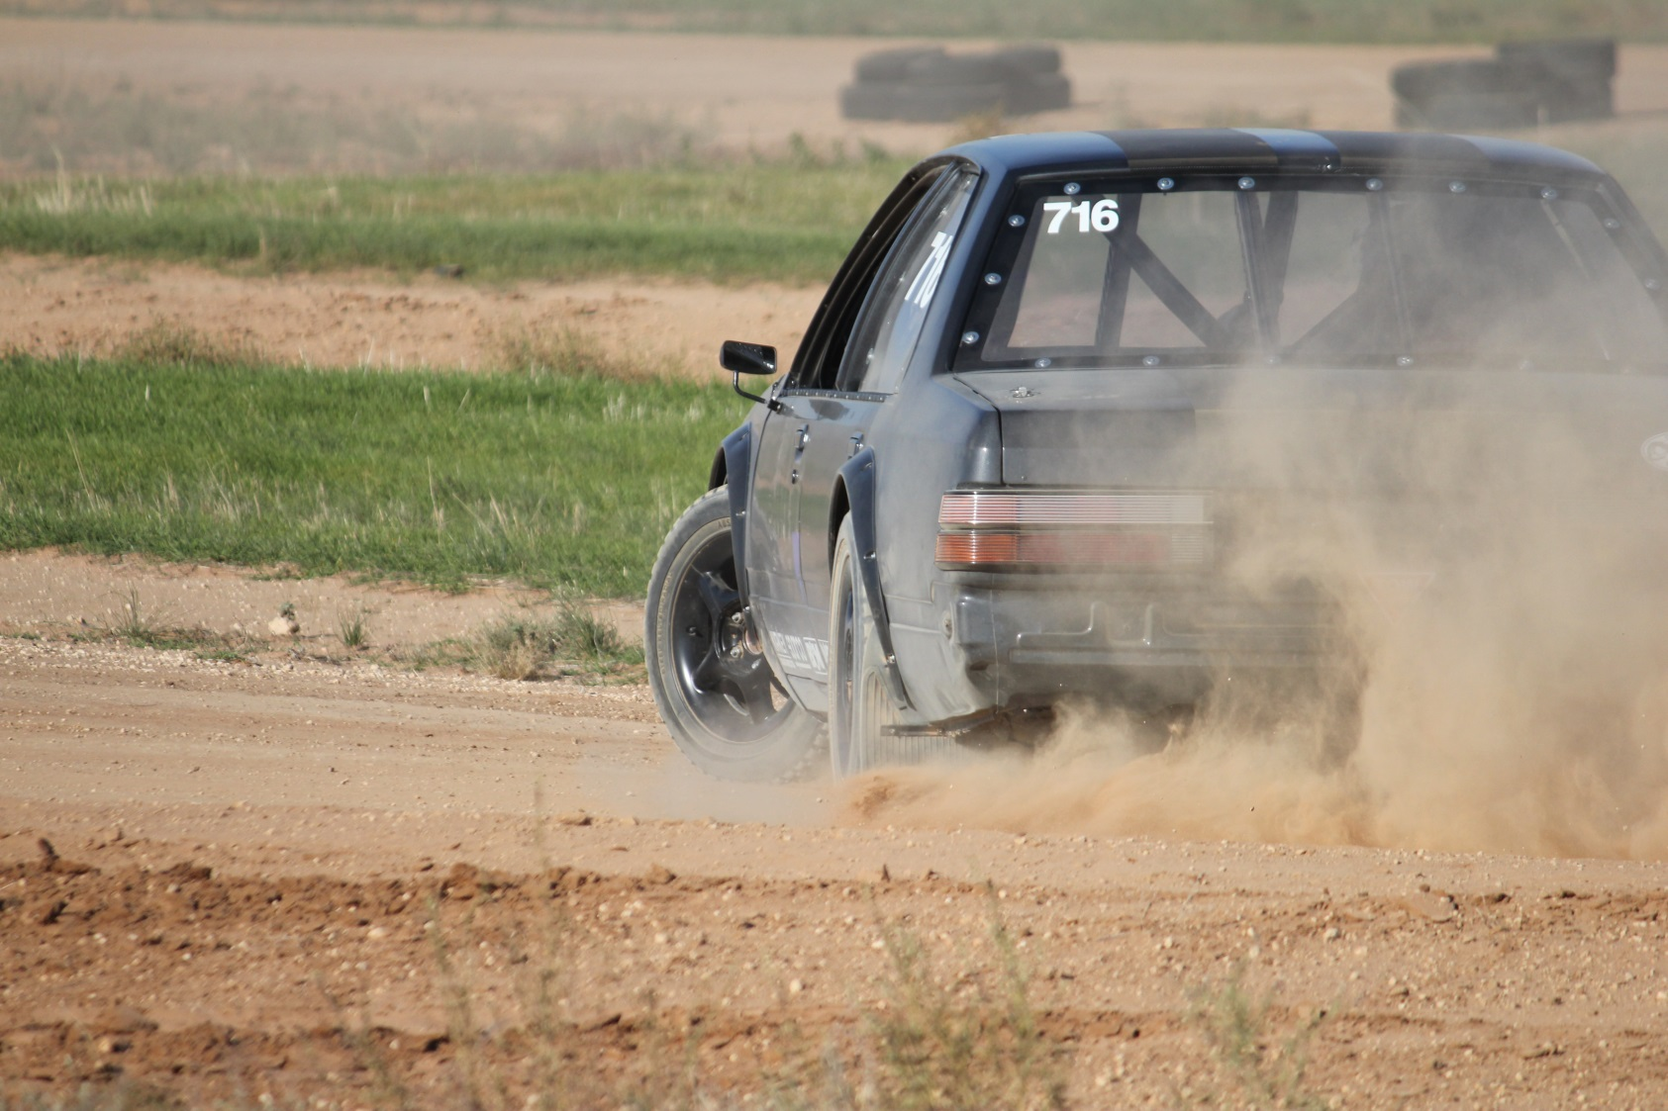

**Swan Hill Sporting Car Club**

**Newsletter**

**May 2017**

**Editor’s Note**

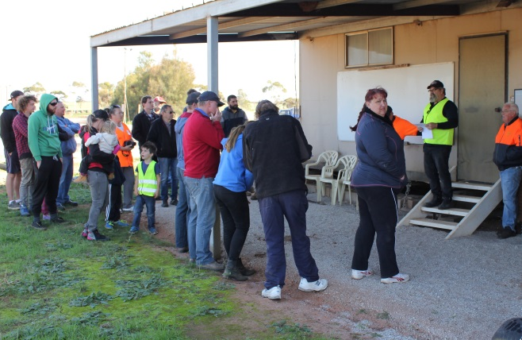Ladies and Gentlemen! As of the 29th of May 2017 the Swan Hill Sporting Car Club has received 1000 Official ‘Likes’ on Facebook! While I’m not sure if there are any prizes involved with this, one thing is for sure, if you stick 1000 people in a room that’s a lot of people. It looks like our itty bitty club is starting to get a Profile, and this is very cool. Congrats (but no prizes either) to Jeff Wadham, who was our 1000th ‘Liker’, and thanks to anyone else reading this who may have also ‘Liked’ us at any point. From little things, big things grow and all that.

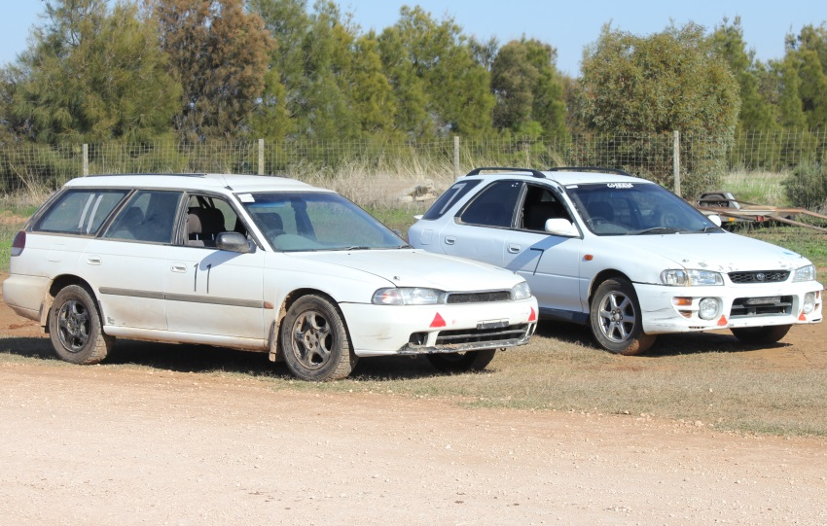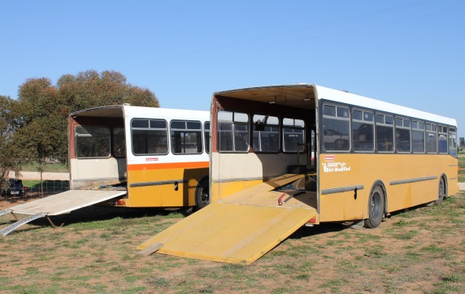Three weeks ago we ran our May T&T. While we thought we’d moved the date away from Mother’s Day it apparently followed us, so it still wound up being Ladies’ Day anyway! Numbers were a little down but with VCAS only 3 weeks down the track, and our Official Club visit to Kyneton sandwiched between the two, there was a lot on this month. And the good thing about having a few less cars than normal was that those who were there got to max out their track time. There was hardly any queue, two lanes and no waiting; if the mood struck you could just about go round and round and round all day long. And some of us did just that. Yes, I’m talking to you, Williamses! And for that matter, the 3 guys who turned up and had a crack in the Club cars – you reckon they didn’t get their money’s worth?

Finally, you’ll be pleased to know Chris G is back in the driver’s seat for this month’s Race Report. But as promised I gave our new/old camera a T&T of it’s own in preparation for our upcoming VCAS round, so the accompanying pics are All My Own Work. For a total noob I think I went ok. For a 7-year-old secondhand camera I think the gadget went amazingly. Hope you enjoy the results!

Rob

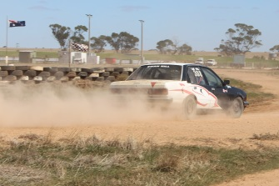Till next month.

Rob

**Prez’s Report, May 14th**

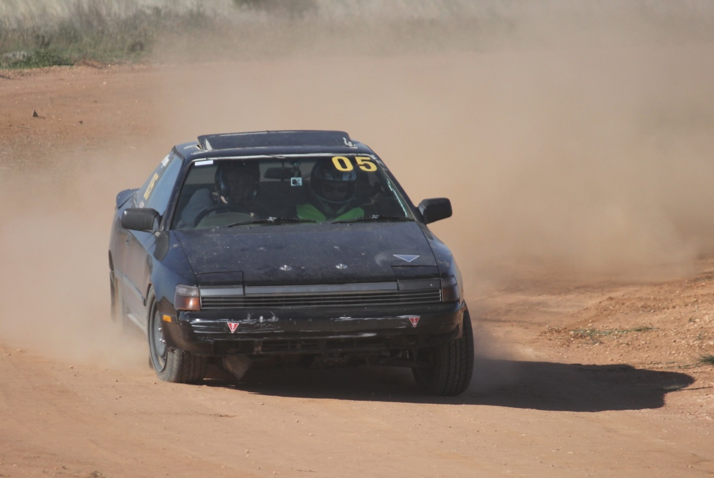Well, it started off with most of us thinking we had moved the date away from Mother’s Day - but as it turned out, Not! Boy there were a few of us surprised, but as we all know s—t happens. Despite it all we had a great day, the weather was awesome and some 18 entries were received. So it’s only fitting that we start with the Ladies.

Rose Pepers asked if I could go for a lap or 2 with her and see if we could find some pace, so first question was ‘How are you doing now?’ and the answer was a fairly consistent time. Now that is great news as you have a good benchmark to work from - very handy, so off we set and I must say that Black Candy does have some get up and go. After a few laps, some tips on how to use a handbrake and throttle modulation, there was a 4 second improvement - and that is getting into some very competitive numbers, so well done Rose!

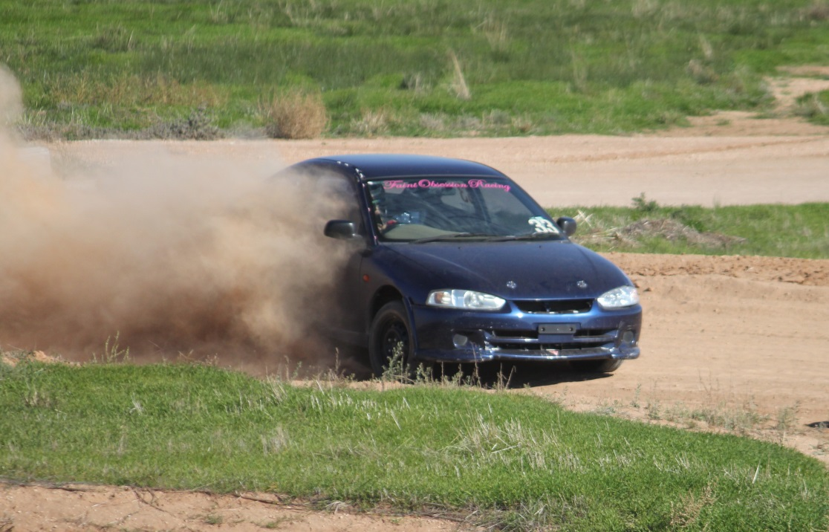

Then Stacey Paynter did a few laps in the car I was running, as I had made a couple of suspension changes and she also drives a Lancer so I suggested she give it a crack. Now this car is a little loud and you could hear the gear changes, so when she came back to check her time I suggested she may be being ‘too nice’ to it, and not to bother with 3rd! She also improved her numbers and was smiling, at one stage holding Fastest 2 Wheel Drive of the Day - that quick.

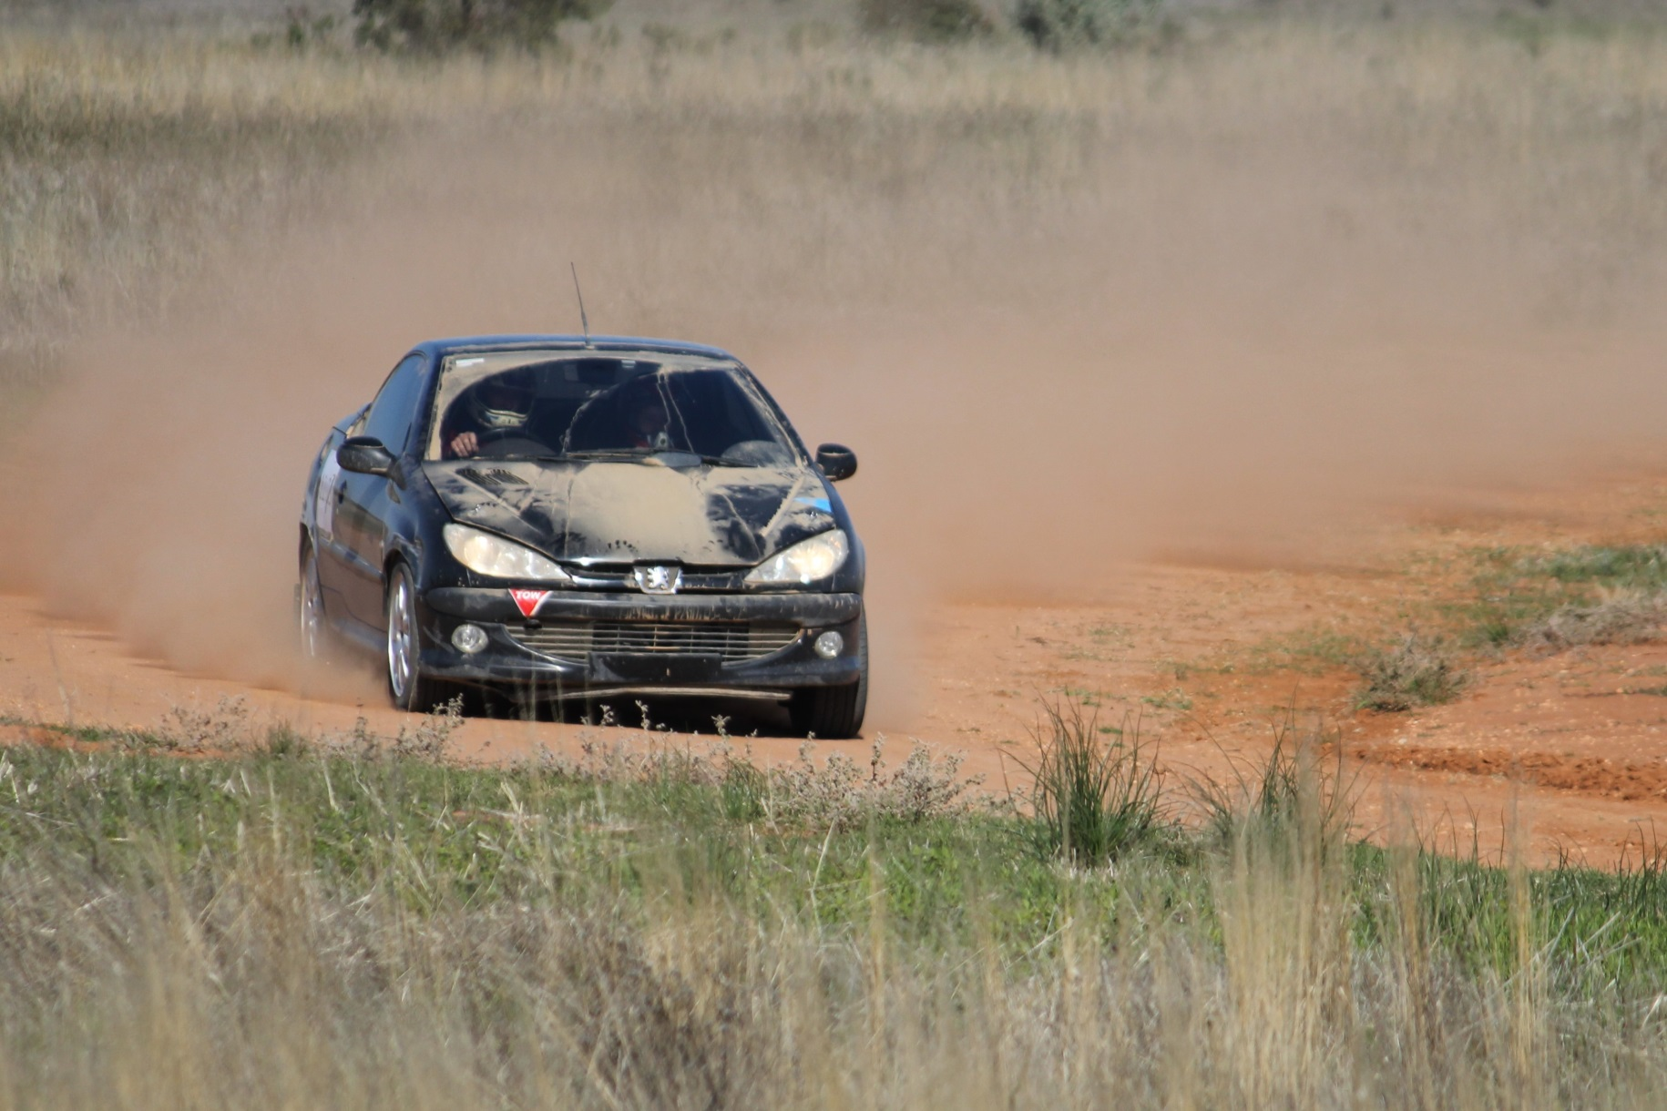Karli Vallence also managed a 1st in Class J. While a little short on competition she was holding her own in the times, with Dad Jason driving the same car only 11 seconds in front of her - pretty good work for the amount of time she has been driving. Well done Karli.

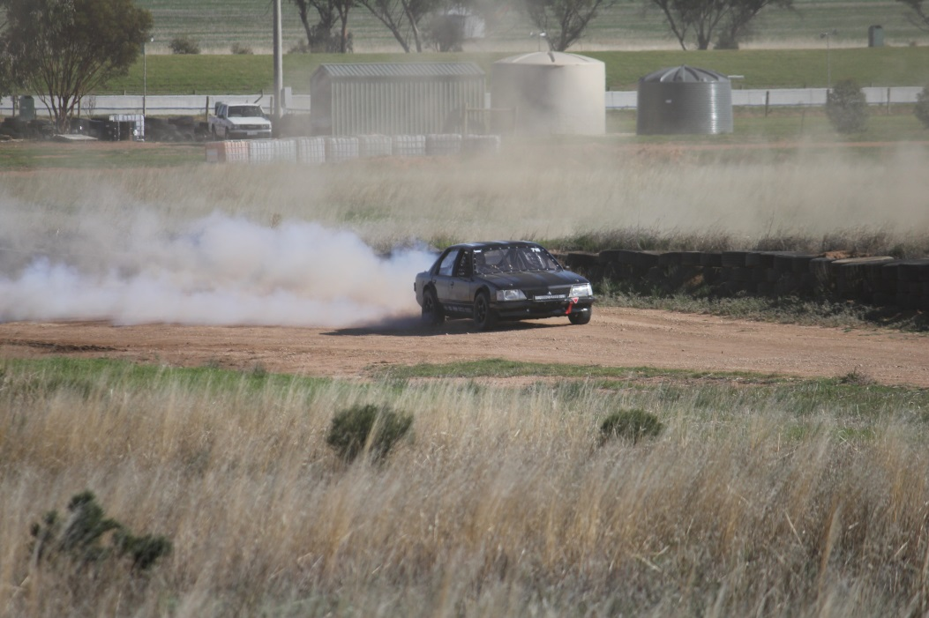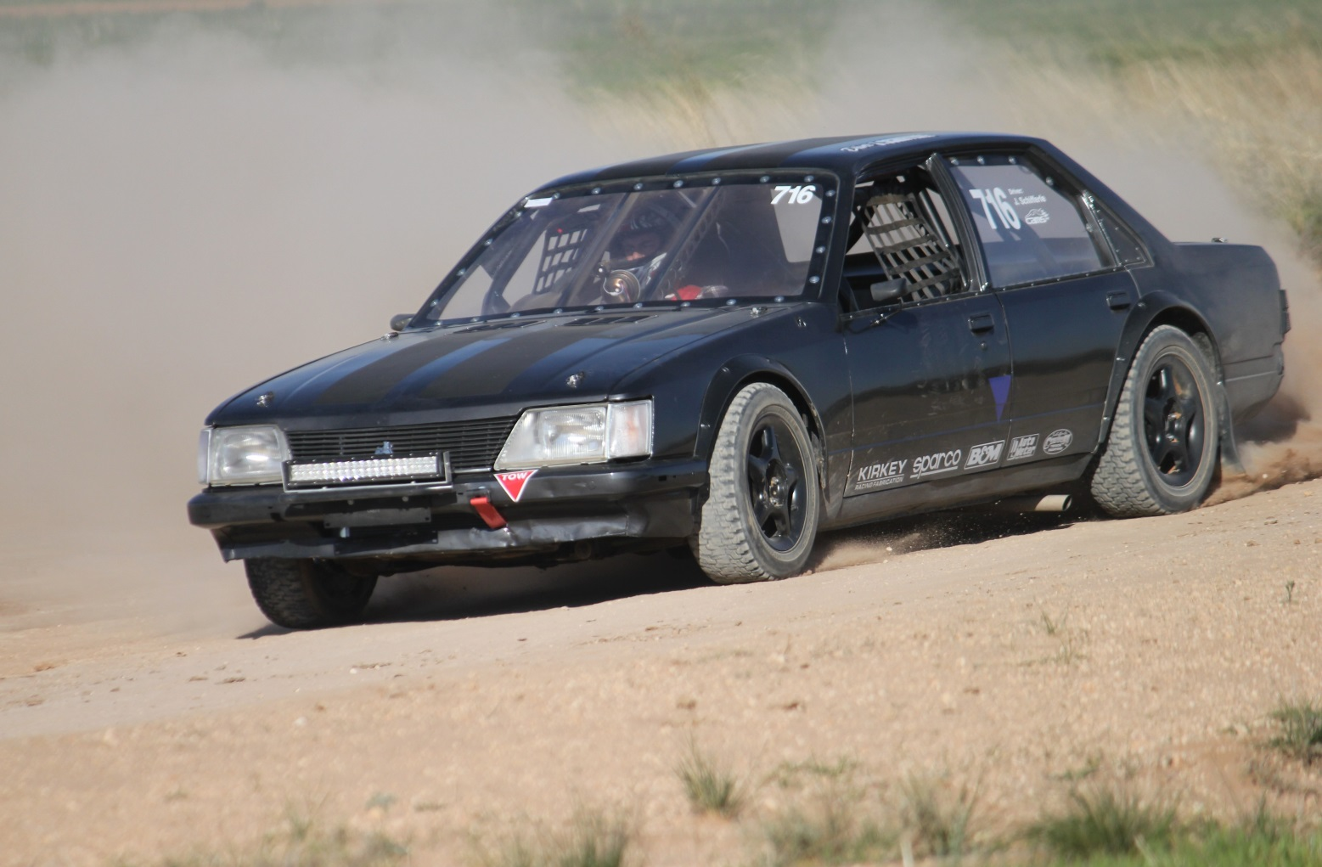Jesse Schifferle was giving his Commodore a good workout, with a few nerves creeping in as after this event the engine was being pulled down for a rebuild and he was not all that confident in it lasting the day; but from where I stood it seemed great. There are some awesome pics of him in action and no matter what you drive you have to love the sound of a V8 at work, still healthy enough to score a 2nd in Class behind Kelvin Jobling.

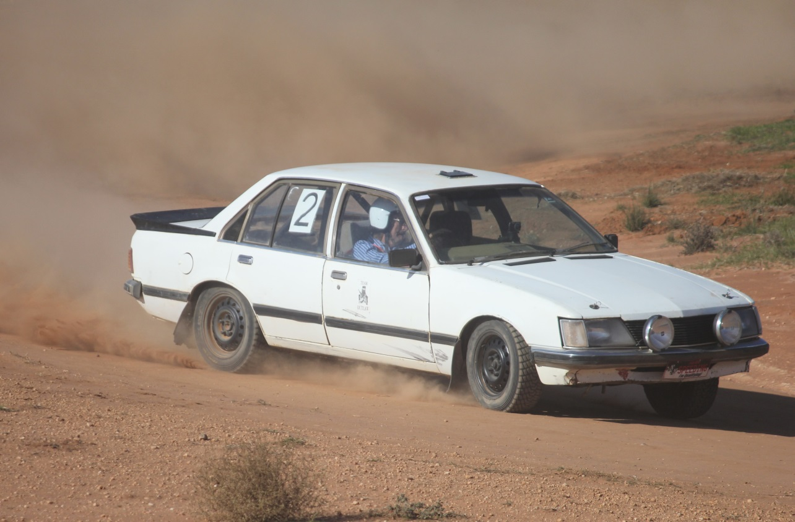And take a good look at the pics of Jobbo, he was driving like a man possessed - always either flat out or full lock or both - unreal to watch.

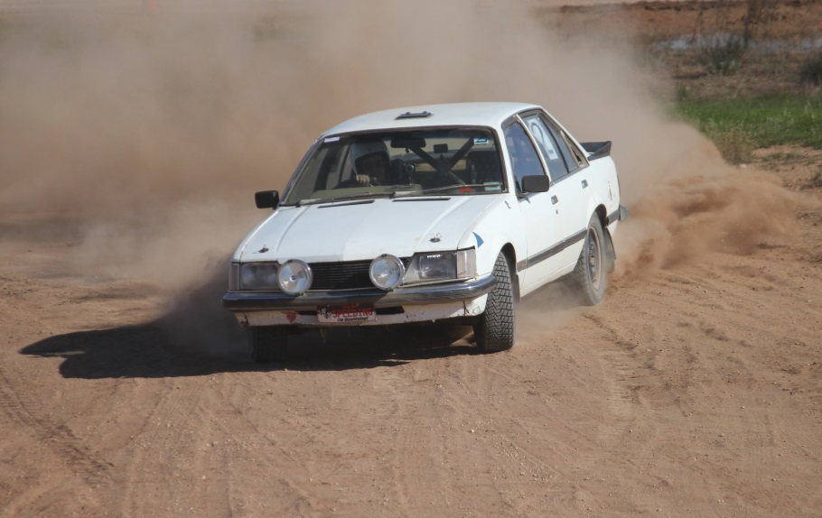

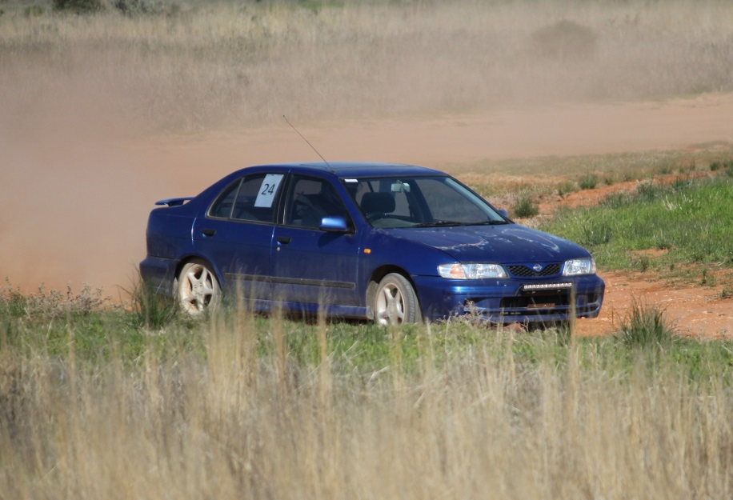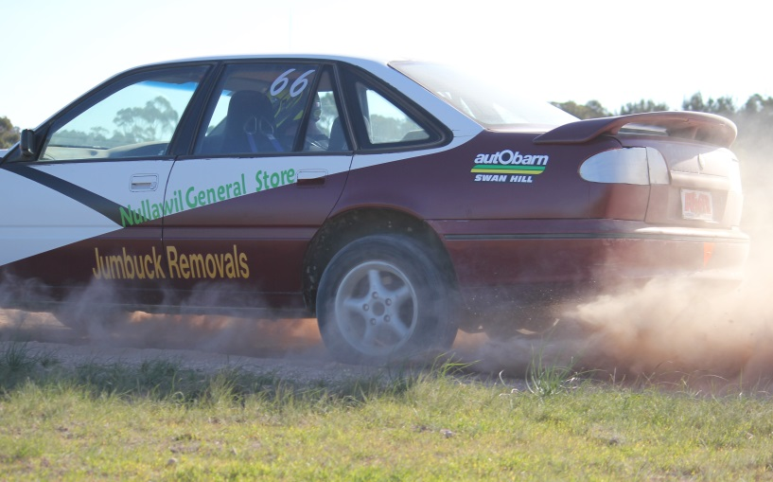It was also great to see Ross Trotter on track in a Nissan Pulsar, he did manage to get in a good number of laps and had a good day as did Justin Obree in the Jumbuck Removals Commodore.

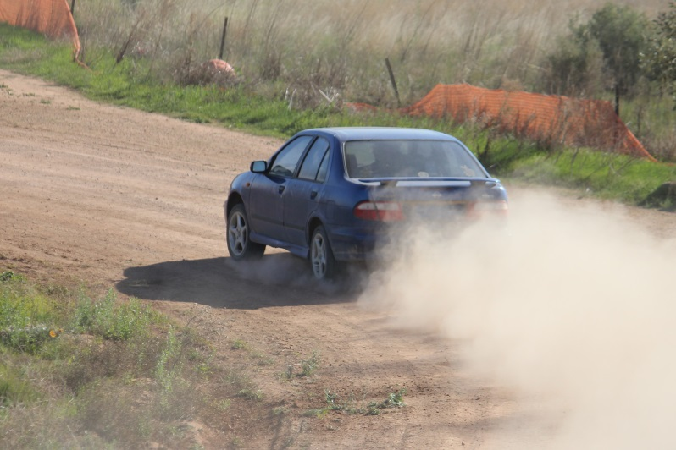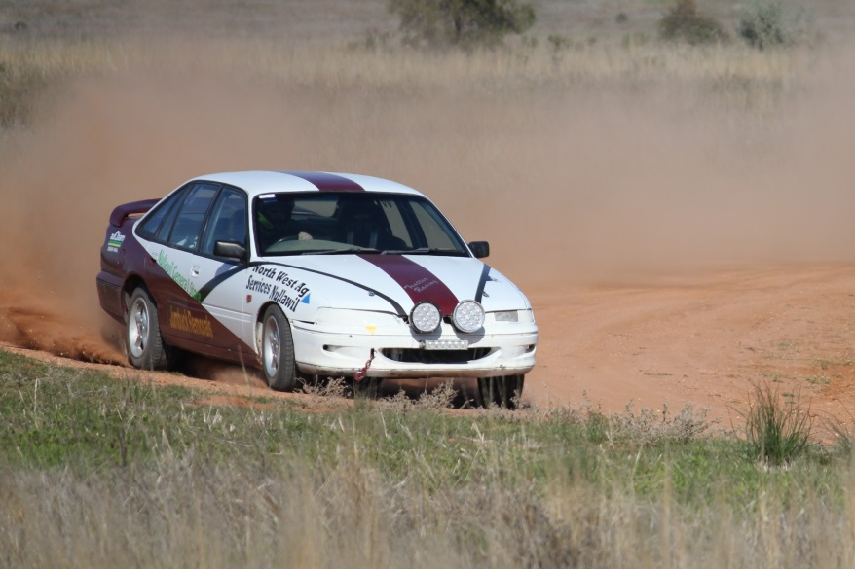

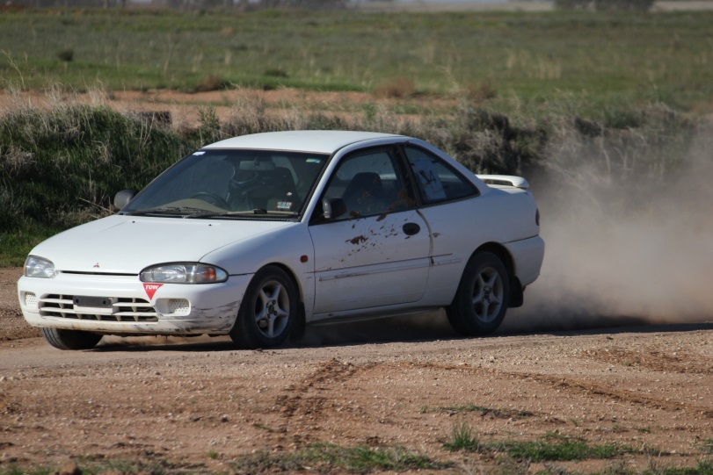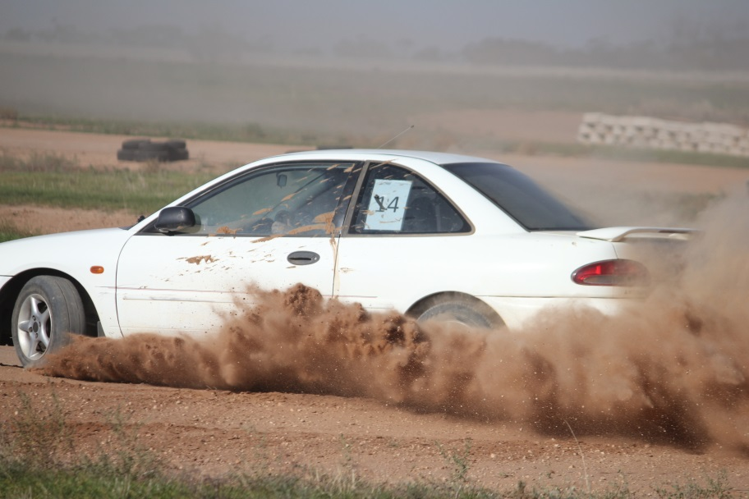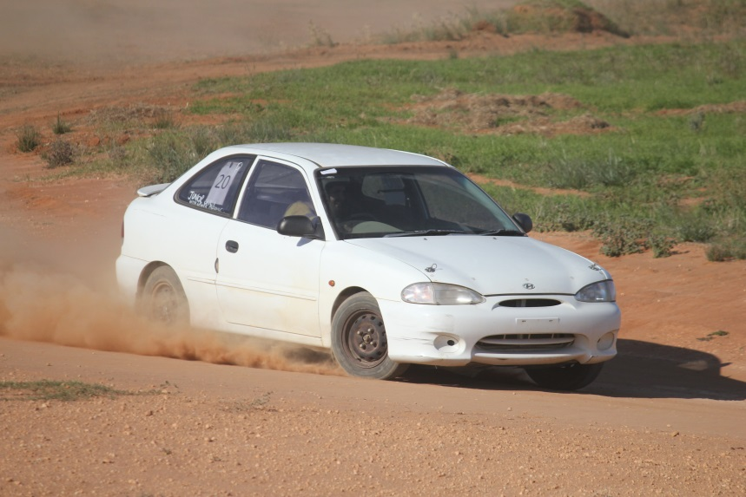Digby Bowring, Jesse and Josh Borlase came out and had a good time in the Club Cars, man they had some fun, got to do lots of laps and seemed to be smiling all day. I think there is some hunting for cars going on at present.

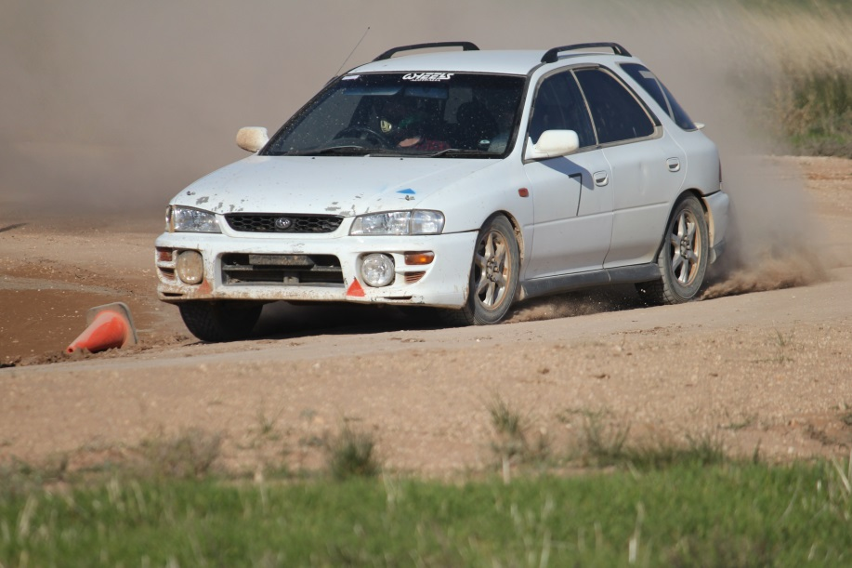

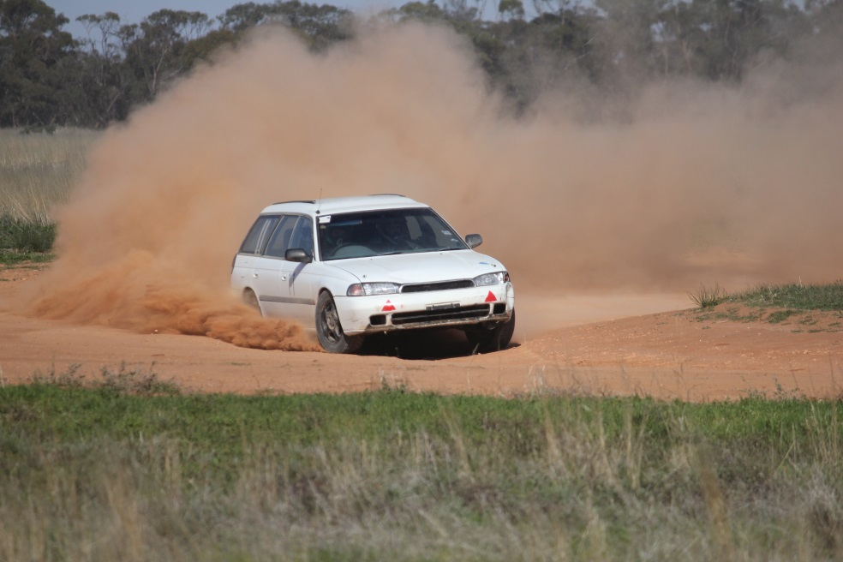Craig and Glenn Williams had a ball in their Suby wagons with Craig taking out Overall Quickest on the day followed by Glenn. Jake Vallence was also running a Suby and managed to get some tips from the Williams boys.

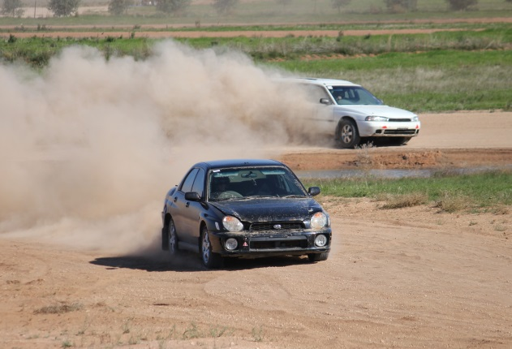

As always there was more that went on but I either missed it or am too grey to remember.

Now on to Kyneton.

**Sunday May 21st Official Visit to the Kyneton Car Club.**

We all know life is what you make it, and life in the Autocross world (or I imagine any sport or club) is the same - you will get out what you put in. Many of us have been able to get out and about a bit over the last couple of years and visit some other Clubs and tracks. Every time we are welcomed with open arms and well looked after, and I believe we do the same when others come to our Club track.

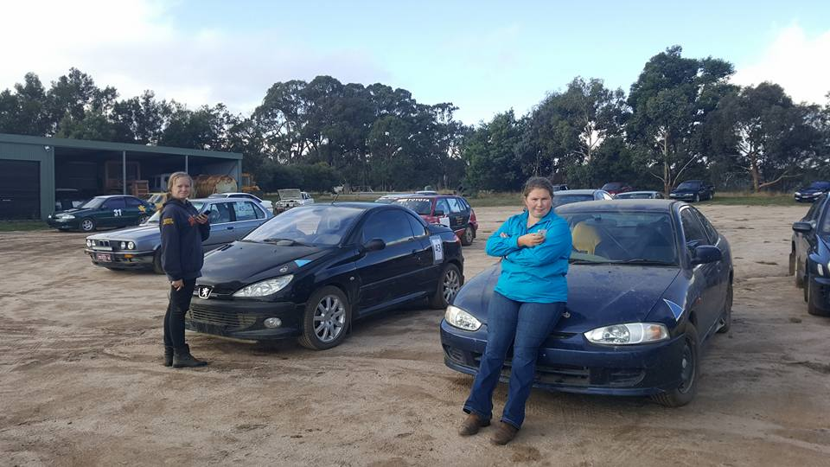Last weekend we went to the Kyneton Car Club and took part in a Multiclub event. 14 members of the SHSCC came along with 6 cars and drivers, and we had a great time (Results on the KCC page). The ladies did well, with Karli Vallence and Anita King-Gee both scoring highly in their class.

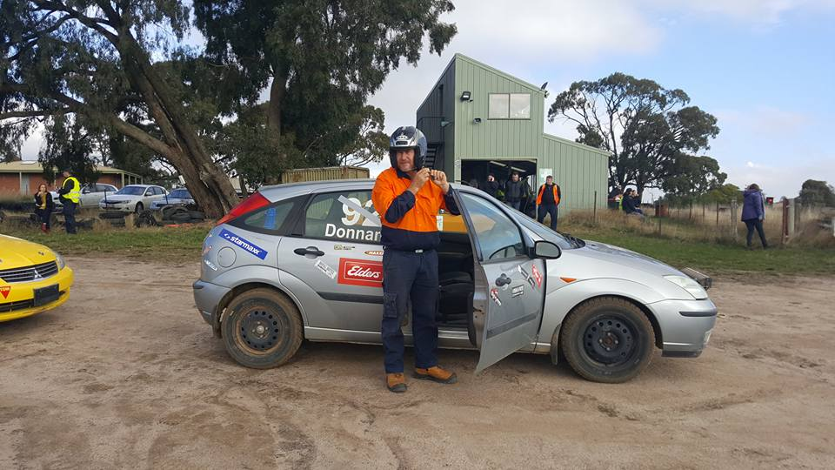 Now Kyneton is quite different to our track, they have the ability to change the configuration of the course and do so every 2 laps. So you do a sighting lap, and then run for 2 laps. They run in numerical order for all laps, and we did that 4 times. There were a total of 50 entries on the day. Starting is on a concrete pad (we would love to have that setup), with the light going green and timing started when you break the beam.

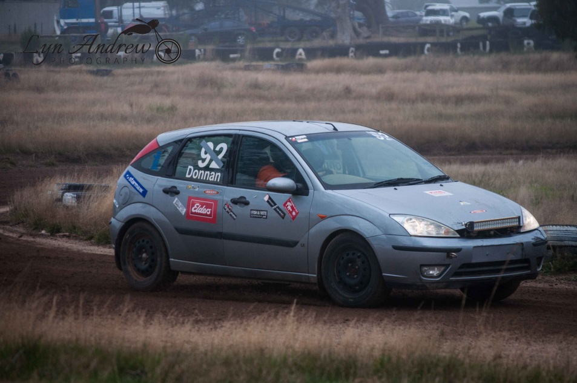The tracks were lots of fun with the changes keeping you on edge all day, but like a trip to Deni, a little local knowledge would help. Ian Johnston was a very happy man; as most of you would have seen on Facebook he has been battling some gremlins in his beast and had never made past lap 5 in Kyneton or lap 4 in Swan Hill, but this time out she made the end of lap 8 loud and proud. I think you will be seeing (and hearing!) it again next weekend in Swan Hill.

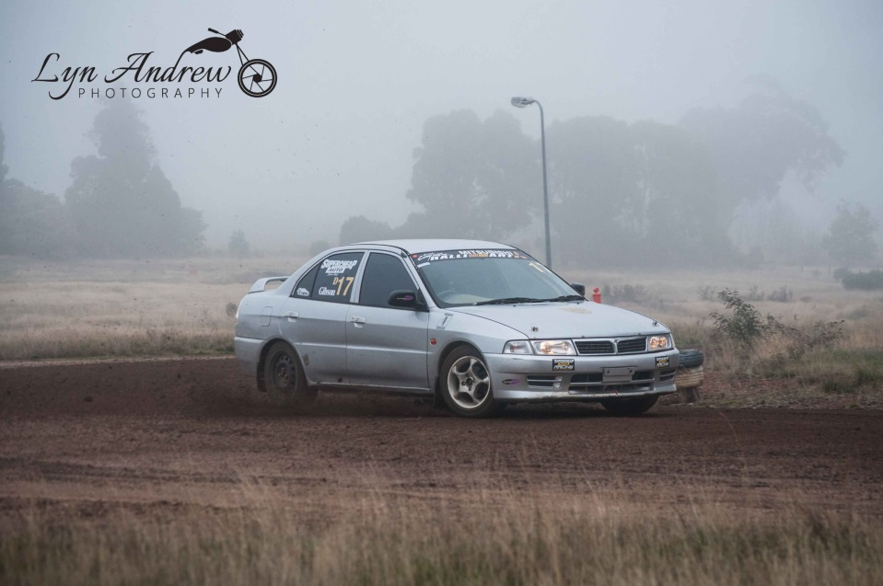Lyn Andrew also made the trip down, as I am sure you have seen by the pics Shirley Caldwell (Kyneton’s Photographer) made Lyn very welcome and they have both got some great pics up on Facebook, or links to them. Well worth a look.

All up it was a great day, very well run and we would love to go back.

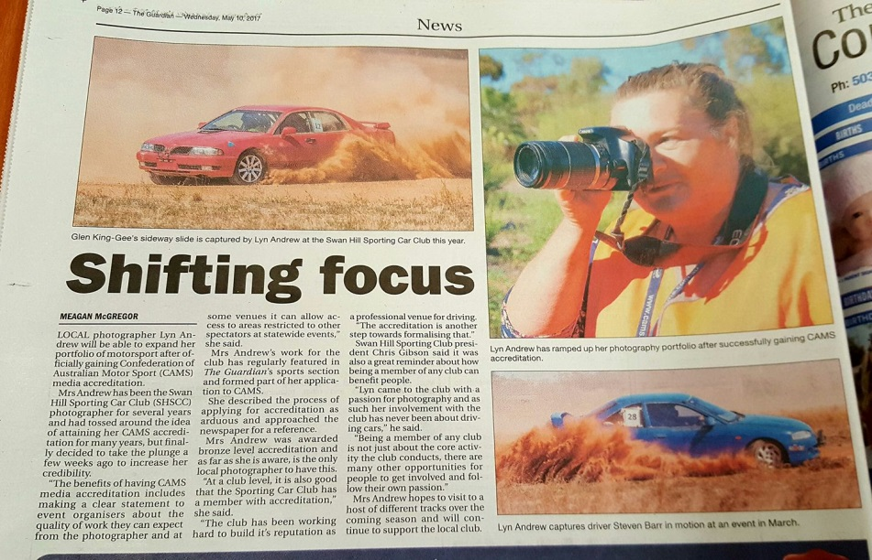

And speaking of Lyn Andrew Photography did you see the spread in the local Guardian on her Cams Accreditation? How good is this? Well done Lyn.

Article from the Swan Hill Guardian

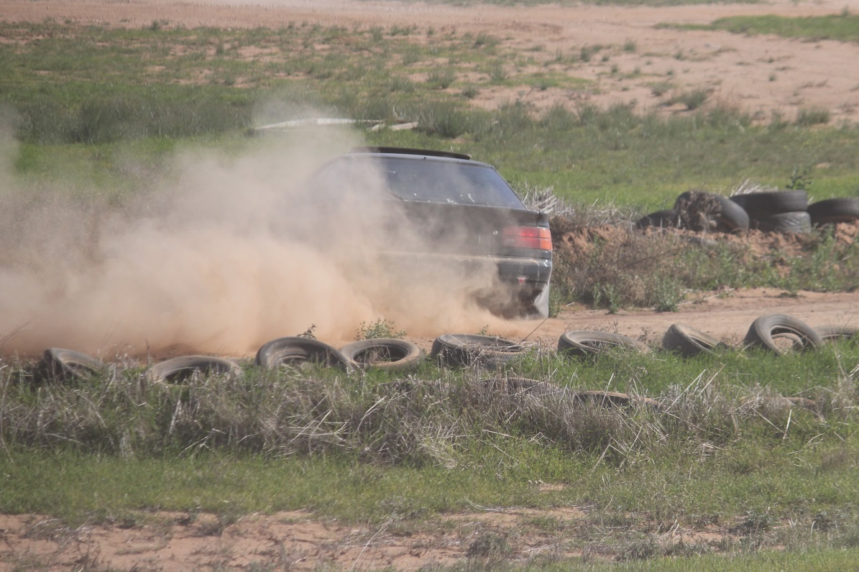

**Tips and Tricks.**

Oops. Now how did THAT get in here…

Hand brake! I know I have mentioned this one before but if you use it to slow yourself before the bend it will help with the line coming into the corner and lead to cleaner lines and better exit speed.

Now we are only talking about a little pressure on it here, not a full -ass lock up. Give it a try.

**Due to circumstances beyond our control the wood fired pizza mob we promised you for the VCAS round social night won’t be coming. Humble apologies. But there WILL be pizza. Oh yes, there WILL be pizza. I promise. Sorry!!!**

*President:* Chris Gibson [president@swanhillsportingcarclub.com.au](mailto:president@swanhillsportingcarclub.com.au) 0422036369

*Vice President:* Neil Albert [vicepresident@swanhillsportingcarclub.com.au](mailto:vicepresident@swanhillsportingcarclub.com.au) 0408307073

*Secretary/Membership Officer:* Stacey Paynter [secretary@swanhillsportingcarclub.com.au](mailto:secretary@swanhillsportingcarclub.com.au)

*Event Secretary:* Lynne Paynter [eventsecretary@swanhillsportingcarclub.com.au](mailto:eventsecretary@swanhillsportingcarclub.com.au)

*Newsletter Editor!/Publicity Officer:* Robert Goff [media@swanhillsportingcarclub.com.au](mailto:media@swanhillsportingcarclub.com.au)

*Club Permit Officer:* Glenn McGillivray [cps@swanhillsportingcarclub.com.au](mailto:cps@swanhillsportingcarclub.com.au)

*Track Manager:* Neil Albert [trackmanager@swanhillsportingcarclub.com.au](mailto:trackmanager@swanhillsportingcarclub.com.au)

**NEXT GENERAL MEETING-**

**WEDNESDAY JUNE 7 - 2017**

**7:30PM**

**LAZY RIVER MOTOR INN.**

Please forward any agenda items to Chris Gibson (President) or Stacey Paynter (Secretary).

**Minutes from last year’s meetings can be found on the club website.**

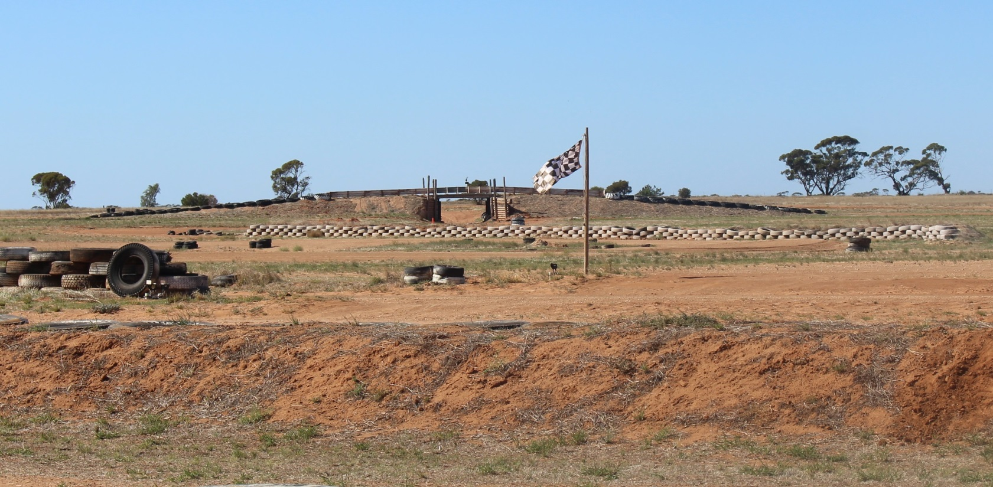[www.swanhillsportingcarclub.com.au](http://www.swanhillsportingcarclub.com.au)

**Calendar of Events.**

**June 3 VCAS Rd 6, Swan Hill + Social Night**

**June 4 SHSCC Test And Tune/Junior Development**

**June 7 SHSCC General Meeting**

**July ?? Official Invite to DECA Sprint – Shepparton - Date TBC**

**July 1 SHSCC AGM**

**July 9 SHSCC Test And Tune**

**July 22 VCAS Rd 7, Maffra**

**August 1 SHSCC General Meeting**

**August 12 SHSCC Multi-Club Event – Day 1**

**August 13 SHSCC Multi-Club Event – Day 2**

**August 20 VCAS Rd 8, Kyneton**

**September 6 SHSCC General Meeting**

**September 10 SHSCC Test And Tune**

**September 24 VCAS Rd 9, Bendigo**

**October 1 SHSCC Test And Tune**

**October 4 SHSCC General Meeting**

**October 15 VCAS Rd 10, Pakenham**

**Nov ?? Official Invite to DECA Sprint – Date TBC**

**Nov 1 SHSCC General Meeting**

**Nov 5 SHSCC 10 Hour Autocross Regularity Relay – Day 1**

**Nov 6 SHSCC 10 Hour Autocross Regularity Relay – Day 2**

**\*\*\*This Event Subject To CAMS Approval\*\*\***

**Nov 12 VCAS Rd 11, Venue TBC**

**Nov 19 VCAS Rd 12, Geelong**

**Dec 3 SHSCC Test And Tune**

**Dec 6 SHSCC General Meeting**

**Dec 9 SHSCC Club Championship Presentation Night/**

**Christmas Party**

A few more random pics of people I’ve missed…

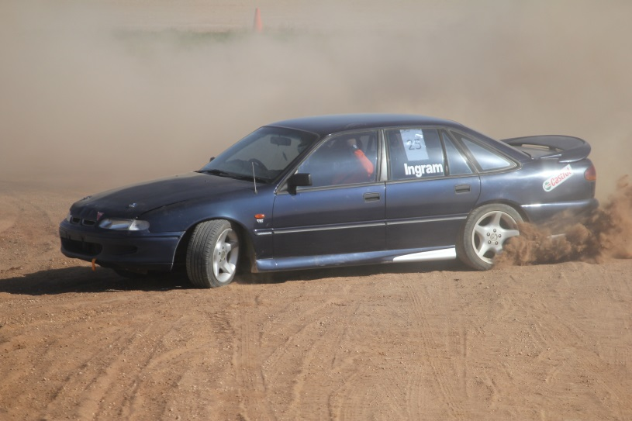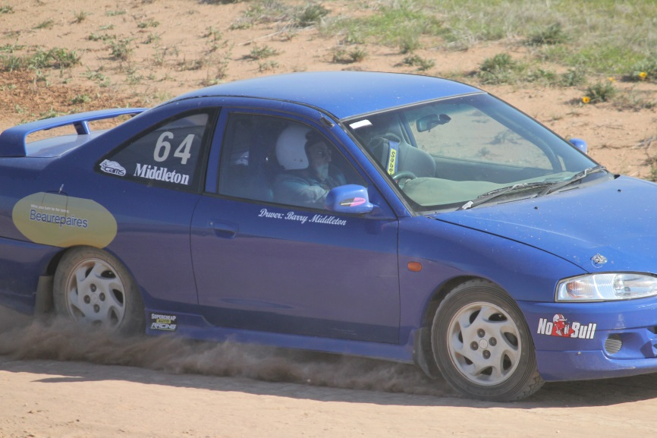

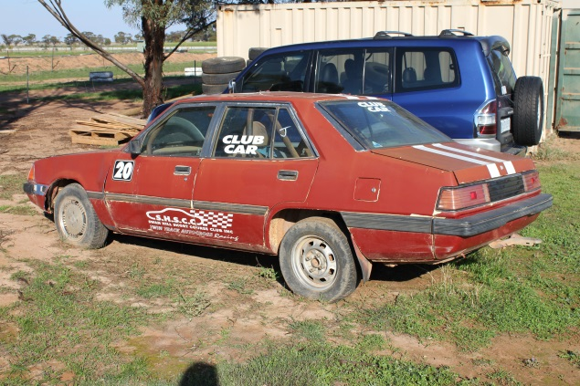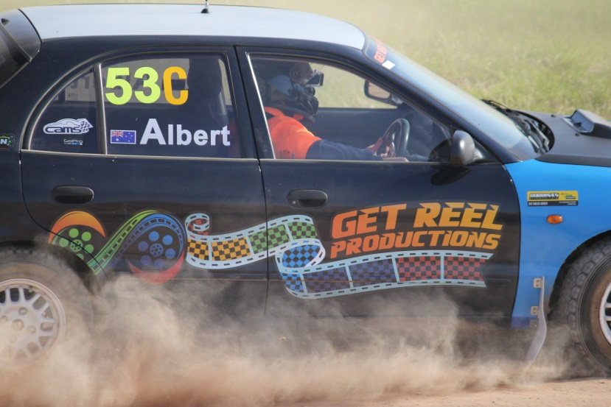

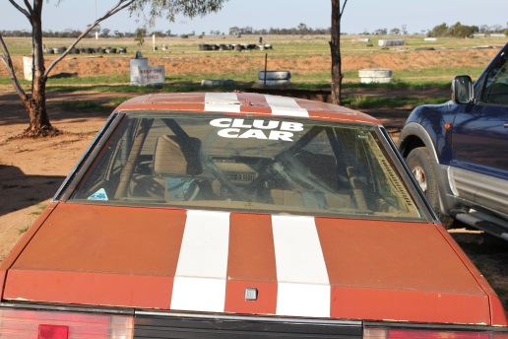

**CLASSES**

In simple terms if it just came off the rood it is **class P**

If you have **done anything** to it and the engine is **below 1600 or 1.6 L it is class C**

If you have **done anything** to it and the engine is **above 1600 or 1.6 L but under 2000 or 2 l it is class D**

If you have **done anything** to it and the engine is **above 2000 or 2l it is class E**

If you are aged from **14 to 18** as of Jan the current year you are **in class J regardless of the car you are driving.**

L Ladies also regardless of car. (Unless it’s Class W)

S Specials (Custom built cars and excessively modified sedans)

W Production Based 4WD or AWD (no tyre restrictions apply)

Below are the more detailed explanations:

**10. CLASSES** (Drivers will be graded into the following classes)

***P***: Standard Production (2WD, Road Tyres Only, No Modifications allowed)

***C***: 0-1600cc Modified (2WD, No Firewall Modifications, Similar Engine Only (Make & No of cyl)

***D***: 1601-2000cc Modified (2WD, No Firewall Modifications, Similar Engine Only (Make & No of cyl)

***E***: Over 2000cc Modified (2WD, No Firewall Modifications, Similar Engine Only (Make & No of cyl)

***J***: Juniors – Aged 14 -18yo as of 1st January 2015

***L***: Ladies

***S***: Specials (Custom built cars and excessively modified sedans)

***W***: Production Based 4WD or AWD (no tyre restrictions apply)

*- Refer the VCAS 2015 Standing Regulations for full details*

When a vehicle is fitted with forced induction the swept displacement shall be multiplied by a factor of 1.7 to determine its nominal capacity.

6.3 When a vehicle is fitted with a rotary [Wankel-type] engine the swept displacement shall be multiplied by a factor of 1.8 to determine its nominal capacity.

6.4 When a vehicle is fitted with a rotary [Wankel-type] engine and forced induction the swept displacement shall be multiplied by a factor of 1.8 x 1.7 = 3.06 to determine its nominal capacity.

**Here are a couple of random items…**

For a non-road-registered series production-based automobile any cable-operated release bonnet mechanism must be disabled and replaced with at least two fasteners which hold the bonnet closed. (Bonnet pins)

Shall display a blue triangle of sides 150mm indicating the location of the battery.

With visible towing points (capable of accepting a 40mm OD cylindrical test object) fitted forward of the front axle and rearwards of the rear axle and capable of towing the automobile on a sealed surface with its wheels locked;

Please go to <http://www.swanhillsportingcarclub.com.au/Tech/default.html> and have a read if you have question great please ask CG or the scrutineers if they do not know they’ll find out for you.

**We Love Our Sponsors**

Meagan from Get Reel Productions has a special offer for club members. A personal profile video where she will attend the track or another location and guarantee a minimum of 2 hours filming focused solely on the individual’s car, driving etc. The completed video is compacted into a 20-45 minute highlight reel complete with music, titles and special effect overlays. Normally priced at $250, Meagan is offering a 50% discount, available to club members for $125. Bookings are essential, please contact Meagan on 0438 615 077 [meagan@getreelproductions.biz](mailto:meagan@getreelproductions.biz)



Head Office – 40 McCallum Street Swan Hill  Victoria 3585

Visiting – (Tiptoe Podiatry) 25 Albert Street Kerang  Victoria 3579

**(03) 5032 4646**

<http://acoustichealth.com.au/>

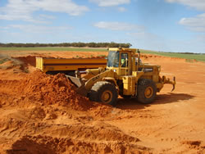

**Contact:** Gary Saville

**Location:** Nyah, Victoria

**Telephone:** 03 5030 2234

**Mobile:**  0427 302 957

**Email:** [gary@coburnsearthmoving.com.au](mailto:gary@coburnsearthmoving.com.au)

<http://www.coburnsearthmoving.com.au>



Coburns Earthmoving specialises in earthmoving and excavations including dam construction, road construction, irrigation, subdivision and general earthworks thoughout Victoria.



Country Tracks 4WD Accessories & Exhaust Centre is located in Swan Hill and is renowned for offering a comprehensive range of accessories from the most credible and respected brands in the industry.  There are accessories for any 4WD vehicle and any type of 4WD user. Customers have the option of having the accessories fitted on the premises, thereby saving them valuable time and money.  14 Chapman Street, Swan Hill VIC 3585(03) 5032 1448 <http://www.countrytracks.com.au/>

****We only use the latest state of the art cameras. We offer a broad range of packages to suit all styles and budgets. Our work speaks for itself, please take the time to look at our sample works provided on [this site](http://www.getreelproductions.biz/).



**[](http://inharmonycounselling.com.au/home)**

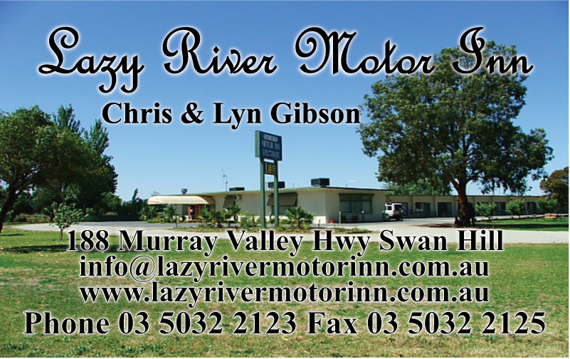

Lazy River Motor Inn with over 2.5 acres and lots of parking. Great for race cars on trailers!!! 188 Murray Valley Hwy Swan Hill Phone Phone 5032 2123 [www.lazyrivermotorinn.com.au](http://www.lazyrivermotorinn.com.au/)

We buy all types of scrap metal in all of Swan Hill, Kerang and the surrounds. Call us and we will come to you.Swan Hill Scrap Metal buy all types of scrap metal, we can pick up from your business, farm or home. All metals including steel, farm machinery, engineering offcuts, data and electrical cable, aluminium, copper, lead batteries, brass or anything metal. Call us and we will do the hard work for you. We are open from Monday to Friday and are available on Saturdays by appointment only. **[](http://swanhillscrapmetal.com/index.html)**(03)503249803Quin Drive Swan Hill



**Lyn Andrew Photography.**

Photos taken at each race event are available for purchase. $20 for copy of all the pictures taken of your car that day with at least 5 edited pics if you supply the USB. $30 for the above if I supply the USB.



**Licence Structure and Pathway**

The Licensing and Accreditation Guide is a reference guide for new and current CAMS Accredited Officials containing information on the National Officiating Program; licence application, upgrade and maintenance; training and development; policies and procedures. Click the link below to download:

[**Licensing and Accreditation Guide 2013-2014** (pdf)](http://docs.cams.com.au/CAMS%20Forms/Officials/Officials%20Resources/Licensing%20and%20Accreditation%20Guide%202013%20vAUG13.pdf)

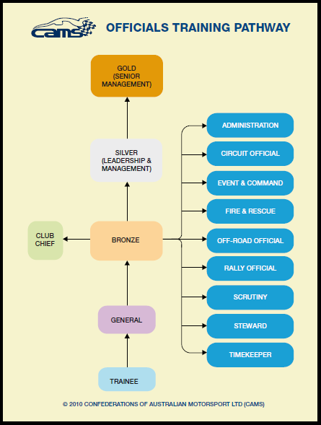 The CAMS Accredited Official licensing structure has two parts: Graded Officials Licences and Non Graded Officials Licences.

Graded Officials Licences have six grading levels and are available to all CAMS Accredited Officials to achieve. Non Graded Officials Licenses have two types: Specialist Licence holders are those that hold professional qualifications and are registered medical service providers. Appointed Licence holders are those that have been appointed by the management of CAMS.

The diagram below shows the licence pathway and the available disciplines in which to specialise at Bronze level. Each of the disciplines in blue have an associated training module, as does General Official (Introductory Module), Club Chief and Silver level. For more information on training modules, visit [Training.](http://www.cams.com.au/get-involved/officials/training)

An official may hold different levels for different disciplines of officiating at any one time (e.g. they could be a Gold Steward and also a Bronze Rally Official). The graded levels are defined as follows:

**Trainee**

For those with no current motor sport officiating experience who are capable of working under direct supervision at all events.

**General Official**

For those with motor sport officiating experience who are capable of working under indirect supervision at all events.

**Club Chief (Club Level Specific)**

For those with motor sport officiating experience working without supervision, capable of performing the role of Clerk of the Course/Event Director, assuming a team-leader role (except Chief Scrutineer) or Chief Steward role at Club/Multi-Club events (excluding race, rally and off road events).

**Bronze**

For those officials qualified to officiate without supervision, capable of performing the role of team-leader (may take responsibility for other officials), officiating as Chief up to and including State level events and act as General Official at any level event.

**Silver**

For those officials with motor sport officiating experience qualified to work without supervision, capable of assuming a team-leader role (and taking responsibility for other officials), officiating as Chief up to and including National level events, and act as a General Official at any level event.

**Gold**

For those officials with motor sport officiating experience qualified to work without supervision, capable of assuming a team-leader role (and taking responsibility for other officials), officiating as Chief up to and including International level events, and act as a General Official at any level event.

Info from <http://www.cams.com.au/get-involved/officials/licence-structure-and-pathway>

**Reminders**

**Race Day Clothing.**

Drivers need to be aware that there are minimum standards for clothing on race day and that clothing standards are part of the scrutineering process. That means that if you are not dressed in your race gear when the car is being scrutineered, then you will have to produce what you are wearing. Below is a summary of what can and cannot be worn when racing. If these standards are not met then you will not pass scrutineering and will not be able to race.

|  |  |
| --- | --- |
| Helmet | Must meet Australian standards. In good condition. No cracks, dents or deep scratches and it cannot be painted. The lining must be in good condition. Fasteners need to be in good condition. |
| Clothing | Drivers and passengers must be dressed in clothing that covers them from neck to ankle to wrists. The clothing can not be nylon. For example, long sleeved Visy tops cannot be worn. |
| Footwear | Footwear can be either shoes or boots. Both need to have a leather upper but can have elastic sides. For example, pull on work boots are ok but nylon sneakers are not. Leather upper sneakers/runners are ok. |

Please follow the link for more in-depth explanation. [CLICK HERE](https://drive.google.com/file/d/0B5lZ_IwrUIFtMzBIbjRYQW5SMFU/edit?usp=sharing)

**Club Apparel.**

Polo Tops, Sweats and Hoodies are now available to order from Blue Sky in Swan Hill with club logo. Please allow adequate amount of time for them to take enough orders to do a run. Prices for the clothing will depend on the size. Logos are available for embroidery on the back (large) and on the front.

**General Official’s Course**- the club needs more Official’s. The first step in the process is to complete a General Official’s Course. Can you please make contact with Lynne Paynter who will advise C.A.M.S. and start the ball rolling.

**Web Site**

Swan Hill Sporting Car Club now has its own web site [www.swanhillsportingcarclub.com.au](http://www.swanhillsportingcarclub.com.au) Please have a look around the site and see what it has to offer. You will notice that there is a forum section. Please register and take part in the forum/s that are of interest to you.